**Tracking Forest Height Growth Over Time with ICESat-2 ATL08**

William Poncy1, Valerie Thomas1, Randolph Wynne1, P. Corey Green1, Phil Radtke1

1Department of Forest Resources and Environmental Conservation, Virginia Tech, Blacksburg, VA, USA

**Abstract**

Quantification of forest structure is necessary for forest inventory, growth prediction, and carbon stock estimates. Since 2018, the ICESat-2 mission has estimated ground and canopy heights in 100-meter data segments across the globe. In this research, we use five years of ICESat-2 ATL08 data to identify canopy height growth in a coastal region of North Carolina, a site selected for its high industrial forest activity. ATL08 canopy height estimations demonstrate strong (R2 = 0.88, RMSE = 2.65 meters) alignment with coincident airborne laser scanning. Because ICESat-2 covers different locations each cycle, equivalence tests were used to show that ICESat-2 coverage locations are equivalent within a margin of 2 meters of canopy height. U.S. Forest Service plots within our study area provide a reference canopy height growth rate of 0.34 meters per year, and a net growth of 1.68 meters over a five-year period. Multiple statistical approaches reveal that canopy height growth is detectable within five years of ATL08 data. However, stratifying growth trends by forest cover type and disturbance history yields nuanced results, as these factors are likely to influence each other. Ultimately, this research aims to serve as a proof-of-concept for using multiple years of spaceborne LiDAR data to identify canopy height growth. Future research should use spaceborne LiDAR to identify growth in other regions of the globe, as solid results could solidify the use of the ATL08 product in global forest growth monitoring.

**Keywords**

remote sensing, forests, LiDAR, ICESat-2

**Highlights**

* ICESat-2 ATL08 data are used to identify canopy height growth
* ATL08-derived growth rates align well with reference data
* Forest cover type & disturbance history have complex influence on growth rates
* Recommendations for tracking forest growth with ATL08 data are provided

**Graphical Abstract**

1. **Introduction**

Supporting forest ecosystems is critical to combating climate change as they are the backbone of the land carbon sink, covering ~31% of terrestrial land area and sequestering twice as much carbon as they emit (FAO and UNEP, 2020; Harris and Gibbs, 2021; Psistaki et al., 2024). However, climatic changes can change tree regeneration capacity and result in stress-induced mortality, altering the species composition of forests (Khaine and Woo, 2015). Additionally, forest disturbance regimes are sensitive to climatic changes, with warming temperatures likely to increase the frequency of fire, insect, and pathogen-based disturbances in coming years (Seidl et al., 2017). To effectively assess forest resilience in the face of evolving disturbance regimes, dynamic ecosystem models require information on forest structural diversity over large scales (Mitchell et al., 2023).

Light detection and ranging (LiDAR) has seen growing use in forest remote sensing. LiDAR can penetrate the canopy layer to describe the subcanopy vegetation and topography of a forest ecosystem, which have strong influence on drought response and wildfire susceptibility (Jarron et al., 2020; Zhao et al., 2022). LiDAR is also used for estimating aboveground biomass of forest ecosystems—an essential task for quantifying the global carbon budget and upholding international climate emissions agreements—more accurately than optical sensors (Neuenschwander et al., 2023; Zolkos et al., 2013). Commonly, LiDAR data is used to describe the structural complexity of forests to infer ecosystem functions by quantifying traits like canopy cover, foliage height diversity, top rugosity, leaf area index, and leaf area density. This study uses canopy height as the primary forest structural characteristic, as tree height data is fundamental to forest management for estimating stem volume, describing stand health, and modeling forest biomass (Chen et al., 2023; Mielcarek et al., 2020).

Airborne laser scanning (ALS) distributes emitted light along an aircraft’s flight path (Maltamo et al., 2014), often used for research at scales larger than individual forest stands. ALS sensor technology can collect data at hundreds or thousands of points per square meter, overcoming the difficulties of traditional sampling techniques in remote or topographically complex areas (Sumnall et al., 2022; Wilkes et al., 2015; Xiang et al., 2024). The spatial coverage of ALS is invaluable for forest research across ecological gradients, with programs like the U.S. Geological Survey (USGS) 3D Elevation Program and the National Ecological Observatory Network Airborne Observation Platform providing ALS data for a range of forested environments. While the accuracy of tree height estimations from ALS are dependent upon species composition, aircraft flight height, and scanner pulse density, LiDAR sensors often underestimate tree height due to the unlikely nature of laser pulses returning from the top of a tree (Yu et al., 2004; Zhao et al., 2018). Multiple studies have found that tree height can be estimated by ALS to within half a meter for pine species (Andersen et al., 2006; Roberts et al., 2005). ALS data from the 3D Elevation Program (3DEP), used in this study, has been used to create high-resolution canopy height models and accurately predict the dominant height and site index of forests (Oh et al., 2022; Ribas-Costa et al., 2024).

Forest height growth is itself heavily influenced by external factors, and estimating year-over-year height growth with ALS could be subject to non-trivial errors due to ALS point density, the method of tree identification in point cloud data, and time interval between measurements (Guerra-Hernández et al., 2021; Socha et al., 2020). Identifying forest height growth with repeat ALS requires ample time between collections for the growth to exceed the noise of single point-in-time measurements. In a study of spruce, pine, and birch, Hyyppä et al. (2003) found stand-level growth errors primarily below 5 centimeters in a 21-month timeframe. Using the same data, Yu et al. (2004) observed that plot-level growth could be determined within 10-15 centimeters. In a study of temperate, mature red pine, Hopkinson et al. (2008) observed an approximate growth rate of 0.3 meters per year, and that the LiDAR-estimated growth falls below an acceptable uncertainty value of 10% after 3 years. Despite impressive performance in estimating forest height and growth ALS data is not without its shortcomings, with collection costs prohibitive to highly repeat or global coverage (Hancock et al., 2021; Liu et al., 2019). Moreover, differences in ALS acquisition parameters even within the same program, namely point density, can yield variability in forest structural estimation (LaRue et al., 2022).

Estimates of aboveground biomass and density are critical to understanding the impacts of land use change on the global carbon cycle (Dubayah et al., 2022). To overcome limitations present in ALS, spaceborne LiDAR missions have been launched facilitating region-to-global scale ecosystem insights (Coops et al., 2021). These missions exchange repeated measurements of small, specific areas for broad spatial coverage, sampling earth’s surface during continued orbit throughout time. When harmonized with other data sources, spaceborne LiDAR data enables the creation of gridded biomass products at regional and global scales (Dubayah et al., 2022; Neuenschwander et al., 2024).

NASA’s Ice, Cloud, and Land Elevation Satellite (ICESat) mission collected global waveform LiDAR data from 2003 to 2009 with a laser altimeter system to quantify changes in polar icesheet elevation (Markus et al., 2017). However, ICESat-derived data products also saw use in efforts measuring land topography, vegetation canopy heights, and atmospheric composition (Schutz et al., 2005). More recently, NASA launched the Global Ecosystem Dynamics Investigation (GEDI) mission in late 2018 to directly assess land surface carbon balance and biodiversity using waveform LiDAR (Dubayah et al., 2020). Building on the success of the first ICESat mission, NASA also launched the ICESat-2 mission in September 2018 to continue measurements of ice sheet elevation through improvements in beam design, along-track sampling rate, and footprint diameter (Markus et al., 2017).

The ICESat-2 satellite employs the Advanced Topographic Laser Altimeter System (ATLAS), a photon-counting LiDAR instrument, to sample earth’s surface (Carabajal and Boy, 2020). ATLAS operates at a 532 nm (green) laser wavelength, optimized for maximal photon detection with current technology. Prior to exiting ATLAS, the laser is split into six beams arranged into three beam pairs, with each beam pair containing a strong and weak beam with an energy transmission ratio of 4:1 (Neumann et al., 2019).

For greater coverage of Earth’s surface, beams within a pair are separated by 90 meters and beam pairs are separated by ~3 kilometers (Markus et al., 2017). ATLAS’s photon-counting technology allows reduced laser power requirement, and therefore a smaller payload aboard the ICESat-2 bus (Sun et al., 2020). With a spacecraft velocity of ~7 km/s and a laser frequency of 10 kHz, the ATLAS instrument achieves an along-track sampling interval of 70 centimeters (Klotz et al., 2020). This generates strong overlap between shots to determine terrain slope both along and across the orbital track. In contrast to GEDI mission which collects data only within latitudes +51.6, ICESat-2 provides near-global coverage between 88° N and S (Markus et al., 2017; Pronk et al., 2024). Moreover, ICESat-2’s orbital altitude of ~500 km and 91-day repeat cycle facilitate analyses of seasonal variation for its coverage areas (Wang et al., 2024)

The consistency of surface measurements by the ATLAS instrument is influenced by atmospheric conditions and land cover attributes. Over highly reflective surfaces like land ice, up to 10 signal photons may be returned per laser pulse. Over vegetated areas with lower surface reflectance, the energy and detection ratio of ATLAS may drop to ~2.5:1, with only 0 to 4 signal photons returned per laser pulse (Neuenschwander et al., 2024, 2023). Though primarily designed for ice sheet monitoring, products for ICESat-2 data have been developed for characterizing ocean elevation, inland water height, and terrestrial vegetation. This research employs the ICESat-2 ATL08 data product, which estimates ground and canopy heights in 20-meter and 100-meter segments.

Assessing the performance of ATL08 segments in estimating canopy heights requires comparison against reference data, commonly from airborne laser scanning. While studies generally report an underestimation of canopy height by ATL08 segments, the magnitude of error varies with forest conditions. In a well-managed, primarily coniferous region of southern Finland, Neuenschwander et al. (2020) reported a mean bias of 3.05 m between ATL08 and ALS canopy heights. Malambo & Popescu (2021) found a mean bias of -1.71 m between ATL08 and ALS canopy heights across six biomes of the US, with the strongest agreement in temperate conifer forests (percent bias: -9.3%, percent mean absolute error: 26.2%), the lowest agreement in tropical/subtropical regions with scattered trees (percent bias: -7.2%, percent mean absolute error: 81.8%), and variation between sites within the same biome. In a wider study across 40 sites in the US, A. Liu et al. (2021) reported a mean bias of -0.77 m, and a mean absolute error of 4.33 m. Canopy height estimation errors are generally minimized in a range of ~40 to ~80% canopy over: sparse vegetation has an inherently low probability of generating photon returns to accurately describe canopy height, while in dense canopy cover photons may inadequately sample the underlying terrain, introducing error into the resulting canopy height estimation (Liu et al., 2021; Neuenschwander et al., 2023, 2020). ATL08 data collected at nighttime with the strong beam of the sensor consistently yield the lowest height estimation errors due to reduced atmospheric interference and greater energy output, and use of weak beam data is generally discouraged for canopy height estimation (Chen et al., 2023; Guerra-Hernández et al., 2022; Liu et al., 2021; Neuenschwander et al., 2020; Rai et al., 2024; Yu et al., 2022).

Ultimately, the accuracy of ATL08 canopy height estimation is a function of many factors, including acquisition characteristics (e.g., beam strength, time of collection), terrain variability, forest density, geolocation accuracy, atmospheric noise, local disturbance history, and temporal coincidence to reference data (Fernandez-Diaz et al., 2022; Malambo and Popescu, 2021; Neuenschwander et al., 2023; Rai et al., 2024). These challenges notwithstanding, ICESat-2’s near-global coverage and high geolocation accuracy (<6.5 m) offer a unique advantage over GEDI to track vegetation dynamics throughout time (Luthcke et al., 2021; Neuenschwander and Magruder, 2019). Still, the question remains as to whether spaceborne LiDAR can reliably detect forest height growth when and where other data sources are not available (Li et al., 2022; Malambo and Popescu, 2021).

By leveraging ICESat-2’s strengths and effectively handling limitations present in its data quality, this study uses multiple years of spaceborne LiDAR to assess forest height growth. To that end, we pose the following research questions:

1. To what extent can ICESat-2 ATL08 detect forest height growth over time?
2. How is this ability influenced by forest cover type and disturbance history?
3. **Materials and Methods**
   1. **Study Area**

Hurricane Florence, a slow moving category one hurricane, made landfall in coastal North Carolina on September 14th, 2018 (Callaghan, 2020). Florence brought record-breaking levels of rain, surpassing 30 inches of rain in some regions of North Carolina, resulting in 53 fatalities and an estimated $16-44 billion in damages to public and private infrastructure (Griffin et al., 2020; Paul et al., 2019). In response, the USGS 3DEP, under the Additional Supplemental Appropriations for Disaster Relief Act of 2019 (H.R. 2157), collected high-resolution ALS data to quantify the extent of hurricane damage and support infrastructure recovery efforts (Hinck and Stachyra, 2019). The study area of this research is defined as the collective boundaries of the 3DEP Hurricane Florence ALS projects (Figure 1). The study area comprises ~5.1 million hectares in the Eastern region of North Carolina.

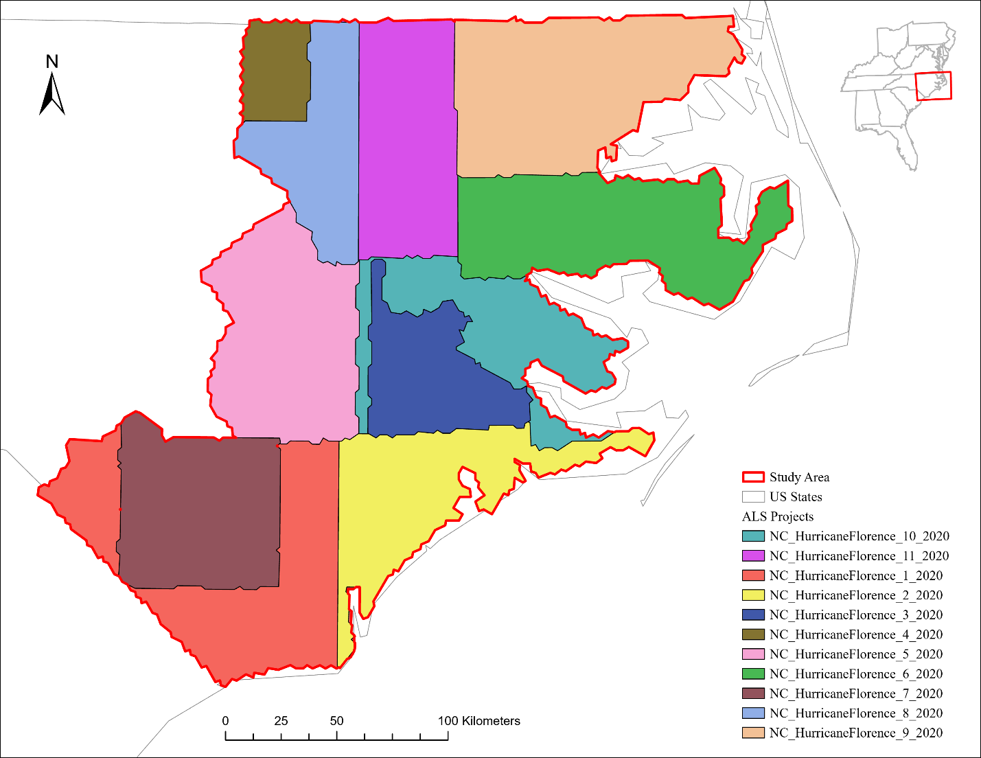

Figure 1: Study area in North Carolina. Polygons indicate boundaries of USGS 3D Elevation Program ALS projects collected in response to Hurricane Florence. Projects were flown in late 2019 and early 2020.

The study area was selected for several factors. Repeat coverage by ICESat-2 is unlikely at the stand or plantation scale, and the collection of data to validate ATL08 canopy height estimations can be financially cumbersome. However, the chosen study area is large enough to ensure repeat coverage by ICESat-2 even after data quality filters, and contains wall-to-wall coverage of high-resolution ALS data. While topography has noticeable effects on ATL08 canopy height estimation (Liu et al., 2021; Malambo and Popescu, 2021), the study area contains low terrain variability, with an elevation standard deviation of 27.3 meters and an average slope of 0.89 degrees (LANDFIRE, Earth Resources Observation and Science Center (EROS), U.S. Geological Survey, 2022a, 2022b). As of 2023, the National Land Cover Database characterizes the study area as predominantly Woody Wetlands (29%), Cultivated Crops (26%), and Evergreen Forest (42%). Finally, the study area falls within the historical natural range of *Pinus taeda* (loblolly pine). As such, the regular tree spacing, consistent tree heights, and fast tree growth observed in the region’s forest plantations should facilitate canopy height growth identification in ATL08 data (Baker and Langdon, 1990).

* 1. **Data Products**

This research utilizes ICESat-2 ATL08 data to track canopy height growth over time. Land cover data from the Annual National Land Cover Database was used to isolate forested regions within the study area. The disturbance history of these forested regions was derived from the U.S. Forest Service’s Landscape Change Monitoring System. ALS data from the USGS 3DEP was used to validate ATL08 canopy height estimations, and assess spatial biases in the locations of ICESat-2 coverage. Finally, data from the U.S. Forest Service’s Forest Inventory and Analysis program provided local, repeat plot surveys for determining expected canopy height growth patterns within our study area. Furter details on each of these datasets are provided below.

* + 1. **ALS**

Hurricane Florence ALS data is contained in 11 projects of the USGS 3DEP flown between December 7th, 2019, and February 28th, 2020. All projects utilized the Reigl VQ 1560i or 1560ii instruments to collect data, meeting the Quality Level 1 requirements of the 3DEP LiDAR Base Specification. This guarantees an aggregate nominal pulse density of >8 points per square meter, and an absolute vertical accuracy (RMSE) of <10 centimeters in non-vegetated areas (U.S. Geological Survey, 2025). With this strong vertical accuracy and high point density, we considered this 3DEP ALS data to be adequate in serving as a reference for ATL08 canopy height estimations. USGS 3DEP LiDAR Point Clouds were accessed on **August 10,** 2025 from m https://registry.opendata.aws/usgs-lidar. A custom Python script was created in Python 3.13.5 to stream the 3DEP data from the Entwine Point Tiles format during data processing (Rossum and Drake, 2010; see code appendix).

* + 1. **ICESat-2 ATL08**

Photon measurements from the ATLAS instrument are aggregated into multiple data products. The Global Geolocated Photons (ATL03) data product records geolocated heights above the WGS84 ellipsoid for all photons downlinked by ATLAS (Neumann et al., 2023). From the geolocated photon data, the L3A Land and Vegetation Height (ATL08) data product is derived through a Differential, Regressive, and Gaussian Adaptive Nearest Neighbor method. This process filters out background noise and estimates land and surface vegetation heights, labelling individual photons as noise, ground, canopy, or top of canopy (Malambo and Popescu, 2024; Neuenschwander et al., 2020; Neuenschwander and Pitts, 2019). The ATL08 product reports several canopy height parameters for segments, including the mean, median, minimum, and maximum of relative and absolute heights for canopy photons. ATL08’s primary canopy height metric, *h_canopy*, uses a segment’s 98th percentile relative canopy height to represent the top of canopy height, as true maximum canopy height may include background noise (Neuenschwander and Pitts, 2019). For this study, all available ATL08 Version 6 granules collected within the study area extent between October 14th, 2018 and December 31st, 2024 were downloaded from NASA’s Earthdata Search (https://search.earthdata.nasa.gov/search) using the Cygwin command-line interface. This provided 740 granules for further analysis.

* + 1. **National Land Cover Database**

To advance research on land surface characteristics within human-environmental systems, the USGS released the Annual National Land Cover Database (NLCD) Collection 1.1 Science Products. This suite of six data products provides annual land cover classification and land change assessments for the Conterminous U.S. for 1985 to 2024. It is created through a framework that leverages geospatial deep learning, continuous change detection, and probability-based post processing against the historical Landsat data record. Within the collection, the Land Cover data product categorizes the earth’s land surface into 16 broad natural and artificial cover types for each mapping year using a modified Anderson Level II classification system (Anderson et al., 1976). While ATL08 segments include native land cover information in the *segment_landcover* attribute, it is derived from the Copernicus Land cover data product at a 100-meter resolution (Buchhorn et al., 2020). The NLCD Land Cover dataset was chosen for this research due to its higher spatial resolution, and alignment with historical forest disturbance data from the U.S. Forest Service. NLCD data used in this research was accessed from the Muli-Resolution Land Characteristics Consortium data archive (https://www.mrlc.gov/data). Land Cover for the Conterminous U.S was downloaded for 2023, provided in a single-band TIFF raster at a 30-meter spatial resolution. Though using land cover data from 2023 yields a 1-year discrepancy with ATL08 data, which extends from 2018 to 2024, this year was chosen for consistency with the most recent year of disturbance data, 2023.

* + 1. **Landscape Change Monitoring System**

The Landscape Change Monitoring System (LCMS) is a suite of remotely sensed data products developed by the U.S. Forest Service to monitor landscape dynamics across the United States. LCMS relies on input spectral imagery from Landsat and Sentinel-2. From these inputs, clouds and cloud shadows are masked, imagery is assembled into an annual time series and temporally segmented, and incorporated with USGS 3DEP terrain data in a random forest model to generate products for vegetation cover Change, Land Cover, and Land Use (Housman et al., 2024).

The vegetation cover Change product is comprised of subproducts that categorize change processes into Fast Loss, Slow Loss, and Gain. Fast loss events indicate an abrupt disturbance to vegetation cover (fire, harvesting, etc), slow loss events indicate gradual structural or spectral decline, and gain indicates vegetation growth or recovery. A summary product is created for each of these processes with pixel values identifying the most recent occurrence of the given change between 1985 and 2023. For this research, the Fast Loss Change summary product for the Conterminous U.S. was downloaded from the LCMS Data Explorer (https://apps.fs.usda.gov/lcms-viewer/).

* + 1. **Forest Inventory & Analysis Program**

The Forest Inventory & Analysis Program is an effort by the U.S. Forest Service Research and Development Branch to monitor the distribution and health of forest resources in all 50 states, U.S. territories, and Freely Associated States ( Republic of Marshall Islands, Federated States of Micronesia, Republic of Palau; Renwick, 2023). A core tenet of the FIA is the Nationwide Forest Inventory (NFI), a network of forest plots that receive repeat measurements every 5-10 years. Depending on the plot, the NFI provides data on land use, soil characteristics, down woody material, understory vegetation, and individual tree height measurements. Though precise NFI plot locations are obscured for privacy concerns, the county of each plot record is specific with Census Bureau FIPS codes—a level of spatial accuracy sufficient for this research (Burrill et al., 2024)

* 1. **Data Processing**
     1. **ICESat-2 ATL08**

Careful handling of all potential sources of error in ATL08 data is necessary to optimize its application for given analyses (Feng et al., 2023; Li et al., 2022, 2020; Rai et al., 2024; Wang et al., 2024; Xi et al., 2022). First, raw ATL08 granules were processed in a custom Python script to extract metrics related to the vegetation conditions, terrain characteristics, and satellite operation for each 100-meter segment (see appendix for code). Segments were geolocated with the GeoPandas library from the *latitude* and *longitude* attributes (Jordahl et al., 2020), identifying the center coordinates of signal photons for each segment (Neuenschwander et al., 2023). The segments were then clipped to retain only those collected within the study area.

ATL08 segments were then processed in a custom Python script to apply data quality filters and intersect with land cover characteristics (see appendix for code). ATL08 segments with invalid (3.402e+38) canopy height values were removed. To minimize biases introduced by low-lying vegetation or high noise, canopy heights were filtered to values between 2 meters and a global maximum (Cao et al., 2016; Li et al., 2020; Rai et al., 2024). Following the approach of Malambo & Popescu (2024), the global maximum for canopy heights was calculated with *k * P,* where *k* is a constant factor of 1.2, and *P* is the 98th percentile of all ATL08 canopy heights in the dataset. For our study area the calculated global maximum was 39.42 meters. This was effective in removing erroneously high canopy heights estimated by the ATL08 algorithm. Further filters selected only segments collected by strong beams at nighttime within the months of May to September to minimize the effect of solar noise and vegetation phenology on canopy height estimation (Neuenschwander et al., 2020). As done by Malambo & Popescu (2024), segments with a multiple scattering warning flag greater than zero or a cloud confidence flag greater than one were removed to mitigate atmospheric interference.

Segment points were intersected with annual NLCD land cover to determine the land cover of each segment’s centroid for the year of 2023. Forested segments were identified by selecting only those with NLCD values of 41 (Deciduous Forest), 42 (Evergreen Forest), 43 (Mixed Forest), or 90 (Woody Wetlands). The segments were intersected with the annual LCMS Fast Loss change product to provide insight into the disturbance history of these forests. For segments with a disturbance event identified by the Fast Loss product, the years since the last disturbance was calculated as the difference between the year of ICESat-2 collection and the most recent disturbance year. For this research, segments with disturbances occurring after the year of ICESat-2 collection were removed, as ATL08 canopy heights may no longer reflect the forest conditions present. Additionally, segments with 3 years or less since the last disturbance event were removed to provide a buffer of forest regrowth and recovery from disturbance.

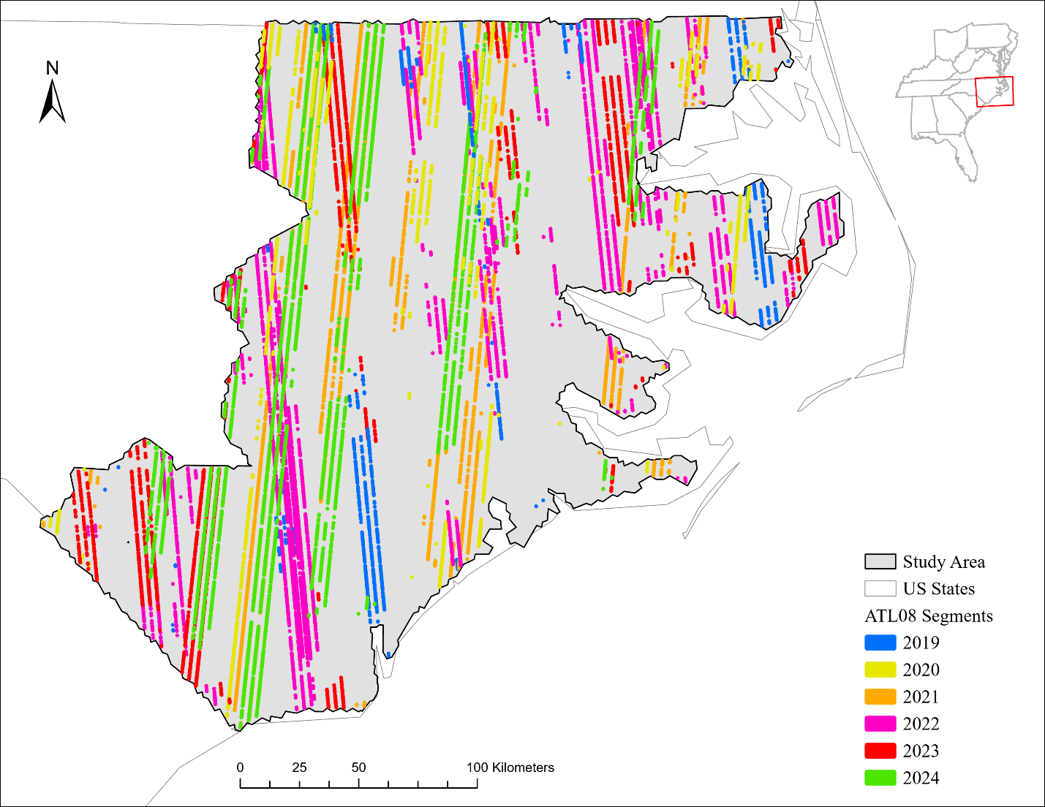

Figure 2: ATL08 segments collected in study area after data quality filters. Segments colored by year of collection to demonstrate ICESat-2 sampling pattern.

* + 1. **Extracting ALS Data Within ATL08 Segments**

For this research it is necessary to extract 2020 ALS data within each individual ATL08 segment. To generate the rectangular polygons of the ATL08 segments, a polygon of 100 x 11 meters was created around the centroid coordinates of each segment, and rotated to align with the ICESat-2 track inclination (see appendix for code; Neuenschwander et al., 2020; Rai et al., 2024). The polygons were reprojected to the Web Mercator projection system (EPSG:3857), which the 3DEP ALS data uses in its native storage format (Hobu, Inc., 2025). These polygons serve as cropping geometries for the ALS data.

ALS data was processed in a custom PDAL pipeline (Figure 3; PDAL Contributors, 2025; see appendix for code). For each ATL08 segment, ALS data was streamed from any 3DEP project intersecting the polygon’s extent. The *filters.smrf* function was used to interpolate the ground surface while minimizing Type I errors (Pingel et al., 2013), which could have yielded inaccurate canopy height estimation. Heights above the interpolated ground surface were calculated with a nearest neighbor approach using the *filters.hag_nn* function (Ribas-Costa et al., 2024). The normalized point cloud was cropped to the geometry of the respective polygon to match the polygon’s along-track inclination (Figure 4).

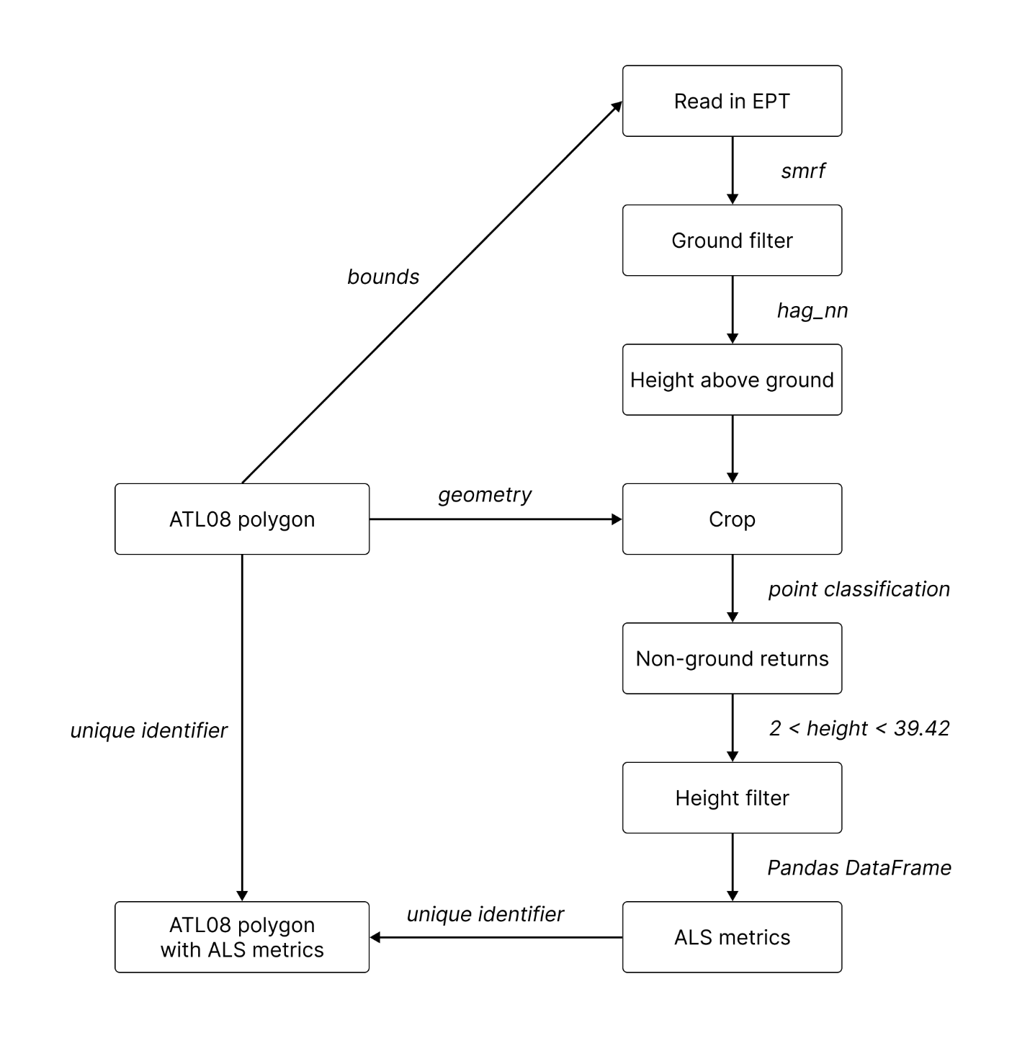

Figure 3: Python workflow for extracting ALS data within ATL08 polygons.

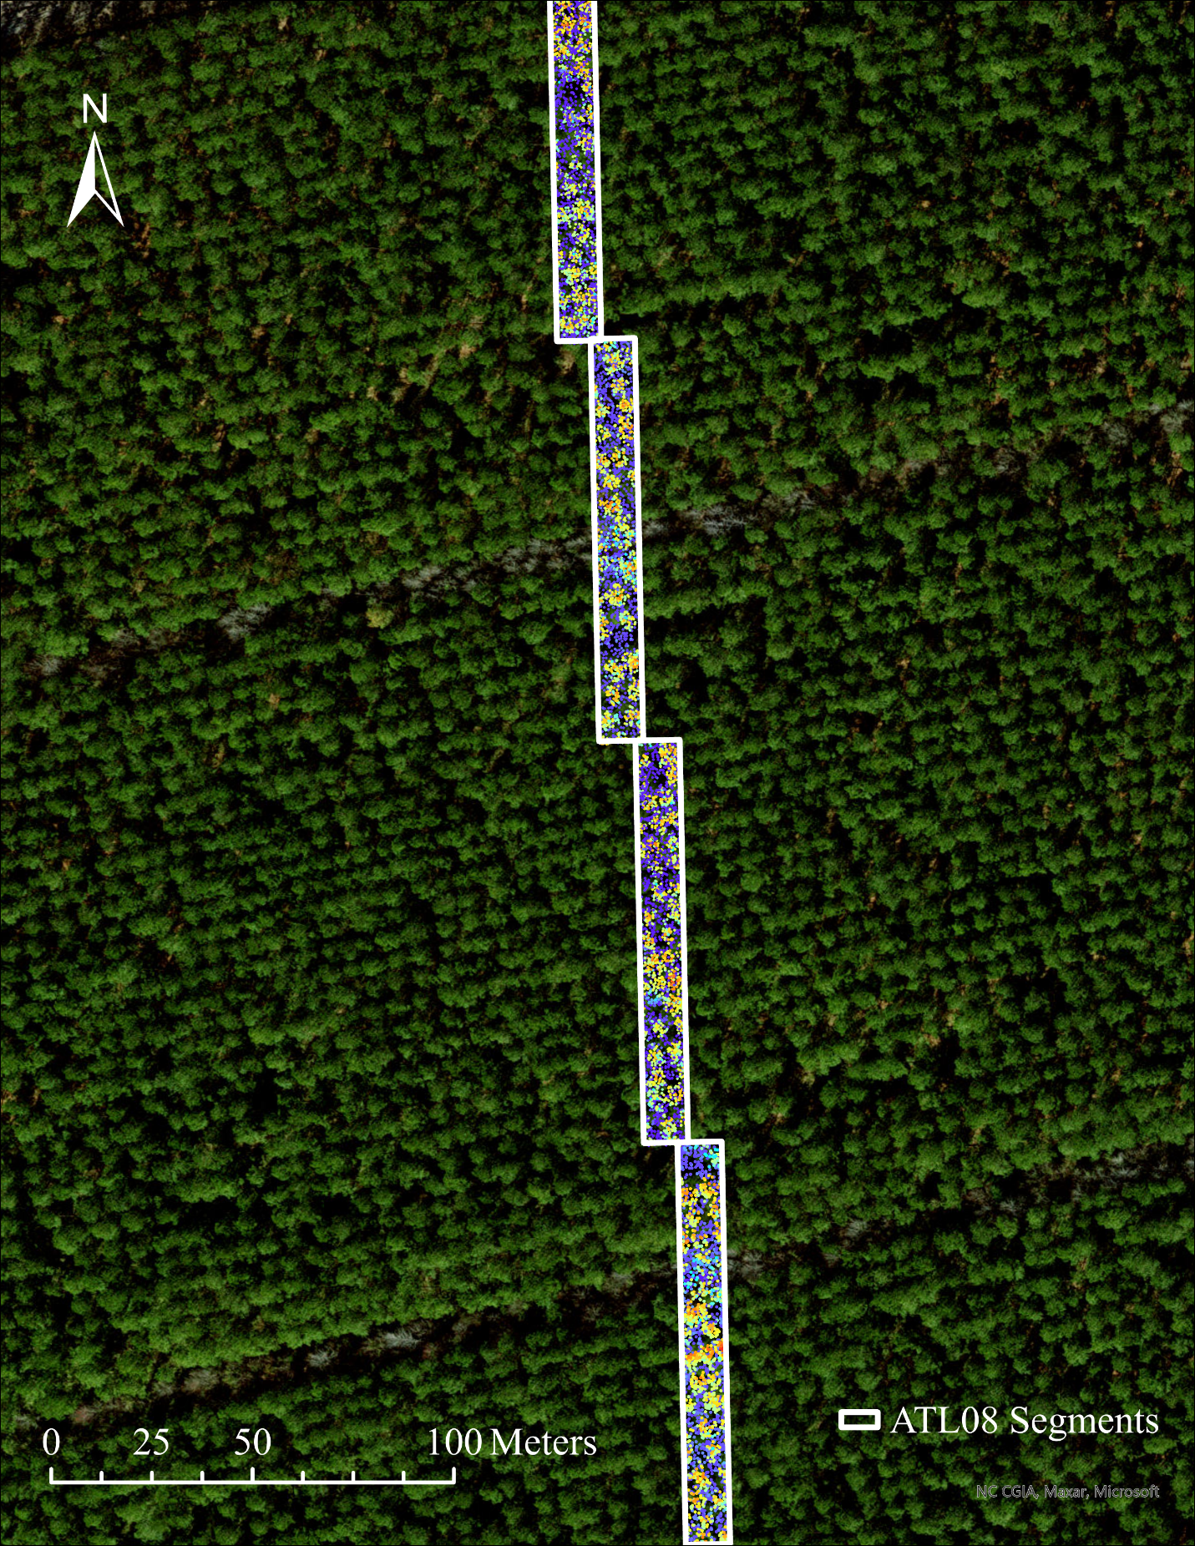

Figure 4: ALS data extracted within ATL08 segments. Segments collected in forest plantation region as shown from World Imagery basemap in ArcGIS Pro 3.4.3 (Esri Inc., 2024). ALS data contains only non-ground returns with reasonable vegetation height as described below.

For each ATL08 segment, the normalized ALS point cloud was converted to a Pandas DataFrame to facilitate analyses (The pandas development team, 2025). To match the filters applied to ATL08 data, we selected only non-ground returns with heights above ground between 2 and the previously determined global maximum of **(39.42)** meters. These were deemed as *vegetation* returns, from which the following metrics were calculated for the return heights: mean, median, minimum, maximum, and the 90th, 95th, 98th, and 99th percentiles. The ratio of vegetation returns to total returns provided an approximation of vegetation density (Neuenschwander et al., 2020). This DataFrame of ALS metrics was joined to the corresponding ATL08 segment using a unique identifier. However, due to the overlapping collection scheme of 3DEP projects some ATL08 segments intersected with multiple ALS datasets, resulting in duplicate segments with vegetation metrics calculated for more than one ALS project (Figure 5).

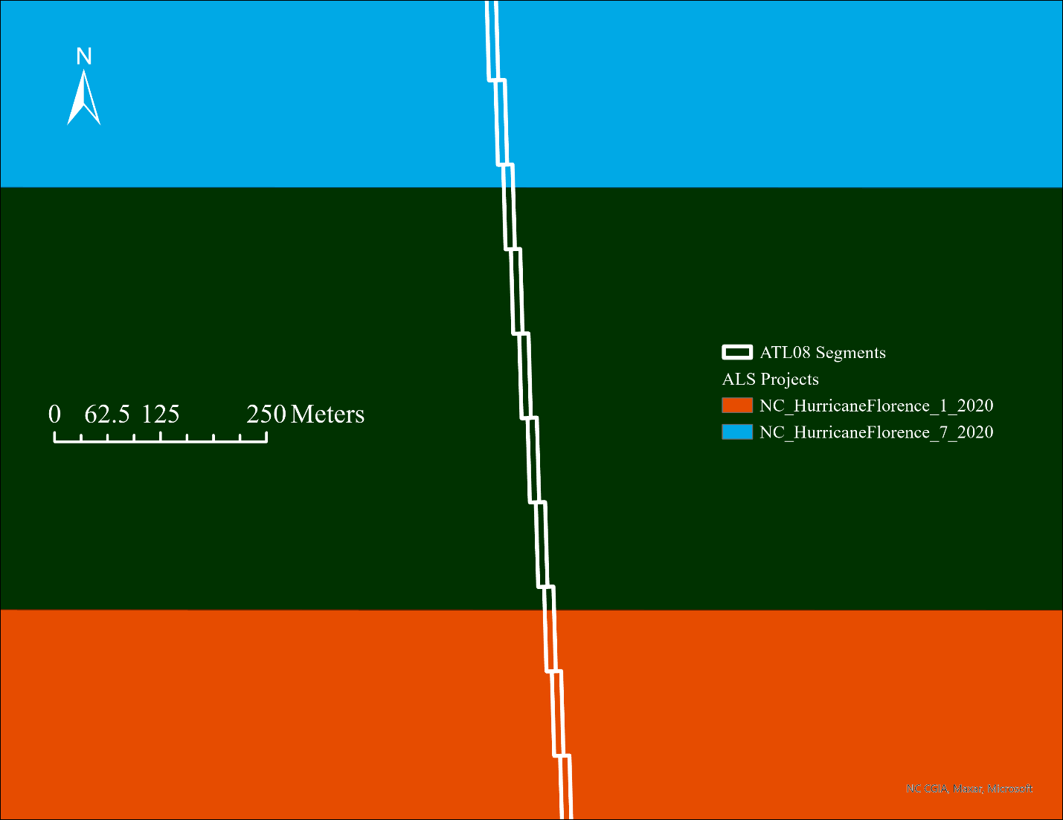

Figure 5: Overlapping collection scheme of ALS projects. Track shown of ATL08 segments (white polygons) passing through overlapping area (green) of separate ALS projects (blue, orange).

In the instance of duplicate segments, only the segment associated with the ALS project providing the highest number of vegetation returns was retained.

Moreover, the 3DEP project boundaries are generalized. Cropping ATL08 segments to the 3DEP Hurricane Florence projects (the study area) yielded some ATL08 segments with no ALS returns within their bounds. These were also removed from analyses, resulting in a final 53,938 of ATL08 segments. In summary, the working set contains 6 years (2019 - 2024) of ICESat-2 ATL08 segments for which vegetation height metrics were also calculated from 2020 airborne laser scanning within each segment’s geometry.

* + 1. **Retrieving Study Area FIA Data**

A copy of the North Carolina Forest Inventory & Analysis database (FIADB) was created in PostgreSQL using a custom repository that provides scripts for manipulating FIA data in a local environment (Radtke, 2025). North Carolina NFI remeasurement plots were accessed using a custom R script **(see code appendix).** This script selected only remeasurement plots in the NFI evaluation group 372023, corresponding to plots in North Carolina (state code 37) remeasured during 2023. These plots were further subset to select only those from the 40 counties within the study area using county code attributes (Figure 6).

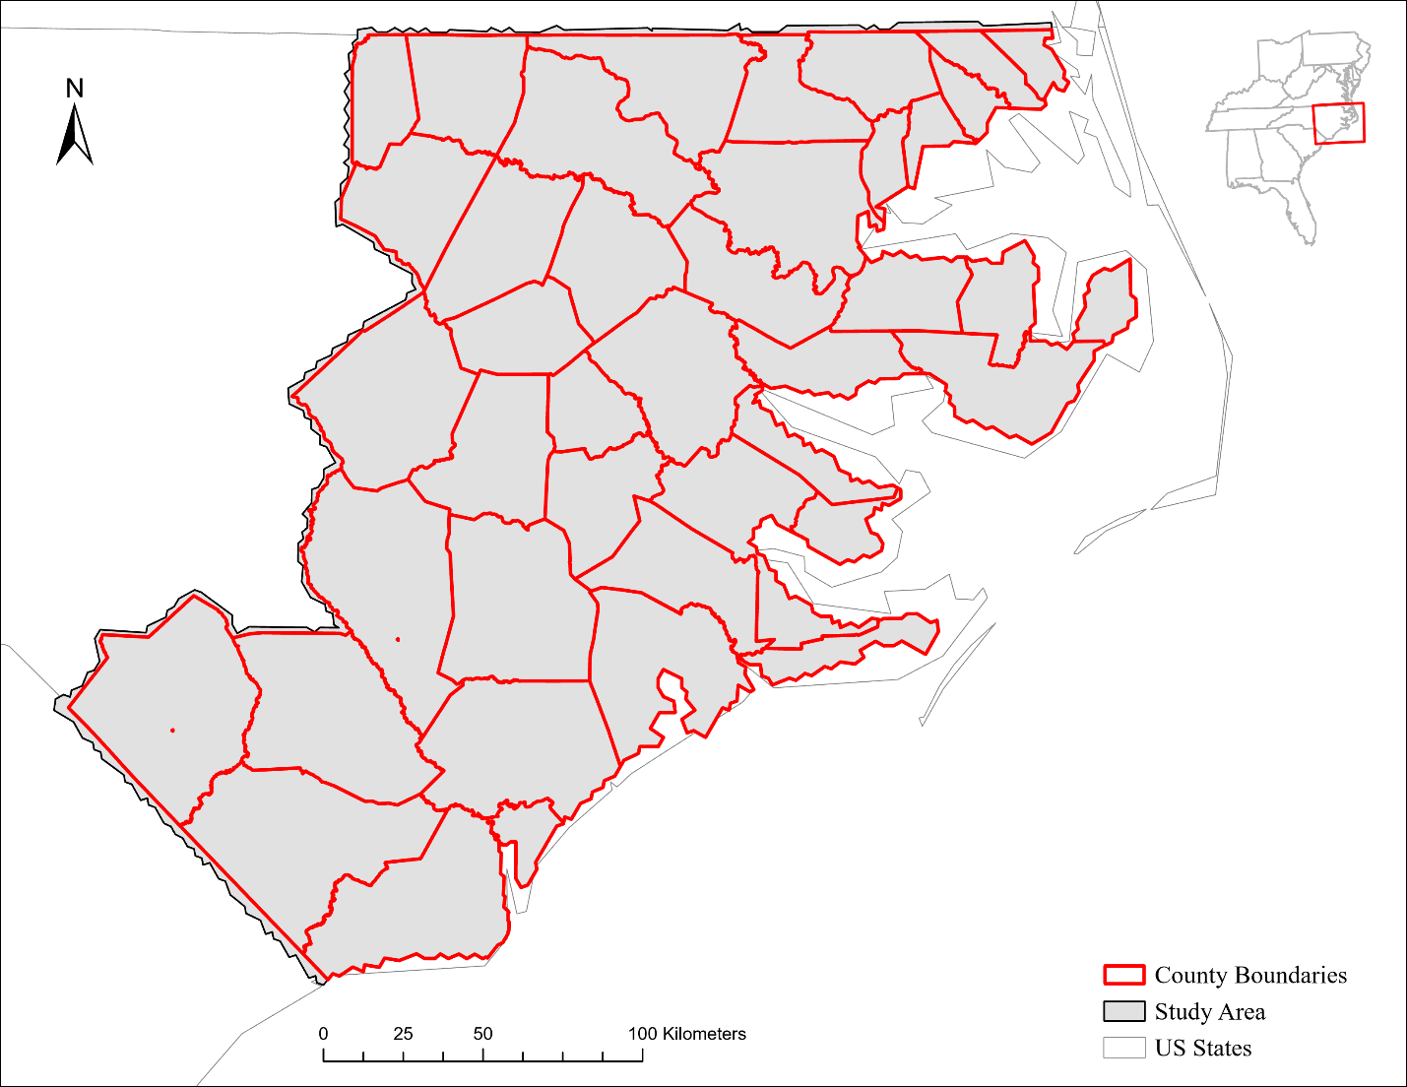

Figure 6: Counties of North Carolina within study area. County boundaries are used to subset NFI remeasurement plots using County FIPS codes.

Unique plot sequence numbers were extracted from NFI plots within the study area counties. For these sequence numbers, the plot, condition, and tree tables were extracted from the North Carolina FIADB. These tables were joined into an R dataframe to provide *current* measurements.

The current record of a remeasurement plot was matched to the record of the previous inventory using the previous plot sequence number. For these previous sequence numbers, the sample plot, condition, and tree data records were gathered from the FIADB. These tables were joined into an R dataframe to provide *historical* measurements.

Current and historical measurements were joined by matching state, survey unit, county, plot, subplot, and species-specific individual tree records. This provided a single R dataframe of individual tree growth data on NFI remeasurement plots to establish reference tree height growth.

* 1. **Data Analysis**

We provide further information about the statistical approaches used in this research in Appendix A. Unless otherwise stated, all statistical tests used a significance (alpha) level of 0.05. Analyses were conducted in R version 4.3.2 (R Core Team, 2023).

* + 1. **Validating ATL08 Canopy Heights with ALS**

Prior to identifying canopy height growth with ATL08 data, it is necessary to establish a strong relationship between ATL08 canopy heights and those from reference data at a single point in time. Doing so allows us to take the reported ATL08 canopy heights at face value. To do so, we use a linear regression to compare ATL08 canopy heigh estimations against ALS-derived canopy heights within the bounds of each ATL08 segment (section 2.3.2).

To align with the timing of ALS data, ATL08 segments were restricted to only those acquired during the year of 2020, resulting in **(validation set)** segments. Though the ALS data was collected in the winter months of late 2019 to early 2020, this was deemed to provide adequate temporal coincidence with ATL08 data. These segments serve as a *validation set* to assess the accuracy of the ATL08 product in canopy height estimation.

For the validation set, the correlation between ATL08 and ALS canopy height metrics was assessed with a Theil-Sen regression model from the *RobustLinearReg* package in R (Hurtado, 2020; see appendix for code). We compared the 98th percentile ATL08 canopy height variable (*h_canopy*)to the 98th percentile height of ALS vegetation returns. From this regression, we report the R2and RMSE.

* + 1. **Addressing Sampling Bias of ICESat-2 Data Collection**

Using ICESat-2 or GEDI to track forest cover change over time is challenged by the transect sampling patterns of spaceborne LiDAR (Mulverhill et al., 2022). ICESat-2 intentionally employs off-nadir pointing at mid-latitudes to fill gaps between reference ground tracks and obtain dense coverage of terrestrial vegetation—ideal for characterizing the global carbon budget, but prohibitive to repeat measurement of individual forest stands (Markus et al., 2017; Neuenschwander et al., 2023; Neumann et al., 2019). As such, each year of ATL08 segment data is a spatially distinct ‘sample’ of the study area **(Figure 7)**

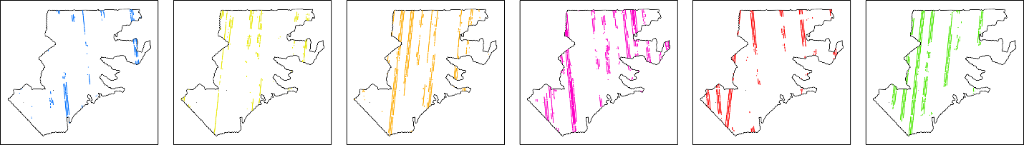

Figure 7: Spatial distribution of each year’s ATL08 segments across the study area. Separate plots unique plots with unique color used for each year’s segments. Each year of ATL08 segments do not align, but shift spatially to provide greater spatial coverage.

Since spatial differences in forest height between these samples may be misinterpreted as change over time, we address two possible sources of bias. To obtain confidence in individual samples, we verify that each sample represents the population distribution of forests throughout the entire study area. To use the samples together to identify changes over time, we also verify that the footprints of each sample are equivalent with each other. By adequately addressing the bias that may exist within ICESat-2 data collection, we can move across space and throughout time to track canopy height growth with the confidence that trends emerge *despite* the samples are distinct, and not *because* the samples are distinct.

* + - 1. **Sample Representation**

To generate the population of forests within our study area, we used NLCD land cover data to randomly select 50,000 pixels from all forest cover types with a custom Python script **(see code appendix)**

For each selected pixel, we create an ATL08 segment at its center and extract the ALS canopy height within the segment **(see appendix for code).** Altogether, the ALS canopy heights extracted within these 50,000 cells comprise the population of forests across the study area.

To establish individual samples as representative, we compare the ALS canopy heights within the footprints of each sample against the population using a kernel density estimate (KDE) plot (**see appendix for code)**. Separate KDE functions were created for each sample. If each sample’s distribution of ALS canopy heights is in agreement with the distribution of the overall population, we can proceed with confidence that ICESat-2 data collection yields representative samples of our study area.

* + - 1. **Sample Equivalence**

To establish the samples as equivalent, we compare the distribution of ALS canopy heights in their footprints against *each other* rather than against the population. We perform equivalence testing with a bootstrapped two one-sided tests technique from the TOSTER package in R (Caldwell, 2022; Lakens, 2017), which is robust to possible violations of the standard t-test (Caldwell, 2025; see appendix for code).

For these two one-sided tests, the equivalence margin corresponds to the difference (in meters) of canopy height between the footprints of samples. These tests were performed at equivalence margin values of 2, 1.5, 1, 0.5, 0.25, and 0.1 meters, spanning a range of interpretations for ‘equivalence’ in canopy height. The equivalence tests employ a Bonferroni-corrected significance level of α = *0.05 / 15* or *0.0033.*

Ultimately these tests aim not to demonstrate perfect equivalence among samples, but to identify samples with noticeable divergence from the rest. Samples displaying noticeable divergence in equivalence testing are removed from temporal analyses, under the assumption of spatial difference in forest conditions that would confound detecting change over time.

* + 1. **NFI-Derived Tree Height Growth**

ata from NFI remeasurement plots are used to determine expected tree height growth within the study area. For this, *actual* *height* measurements from FIA plots are used rather than *total height* measurements, as actual height measurements use the canopy surface which would be sampled by LiDAR scanners, while total height measurements may involve subjective estimation for trees with broken tops (Burrill et al., 2024). We used measurements only from live trees by removing dead trees with the tree status code. Moreover, we subset to only plots with a remeasurement period that matches the timeframe of our ATL08 segments, as NFI plots have remeasurement periods ranging from 5-10 years (U.S. Department of Agriculture Forest Service, 2025). From each tree, we calculate the annual increment and net growth in tree height. Increment represents the annual, year-over-year growth for individual trees calculated as:

$$Increment=\frac{{Height}_{actual, current}- {Height}_{actual,previous}}{Remeasurement Period.}$$

Net growth scales the annual increment to determine total growth over time, calculated with:

$$Net Growth=Increment*ATL08 Segment Timeframe$$

Records with negative net growth—possibly resulting from errors in the NFI sampling protocol or damage from disturbance events—were removed. Importantly, NFI measurements are collected for individual trees. To align with the spatial scale of ATL08 segments, we aggregate individual tree measurements up to the plot level, and report the median value of increment and net growth across all trees within each plot. Distributions of plot-level increment and net growth are summarized into minimum, first quartile, mean, median, 3rd quartile, and maximum values, and visualized with histograms to provide insight into typical annual and cumulative forest growth patterns in the study area **(see appendix for code).** These metrics from NFI plots serve not as ‘targets’ to hit when tracking growth with ATL08 segments, but additional context.

* + 1. **Assessing Canopy Height Growth with ATL08**

We used multiple statistical approaches to identify canopy height growth in ATL08 segment data across the following three factors:

* **Forest cover type:** Deciduous Forest, Evergreen Forest, Mixed Forest, Woody Wetlands
* **Disturbance presence:** Yes, No
* **Time since disturbance:** <10 Years, 10-20 Years, 20-30 Years, 30+ Years

A Wilcoxon Rank-sum test was used to determine net growth in canopy height by comparing the first and last years of ATL08 segments. This one-sided test uses an alternative hypothesis that the canopy heights in the last year are significantly *greater* than those in the first year, indicative of growth over time. For the Wilcoxon test we report the difference in median canopy height between the first and last year of segments as a proxy for net growth, and the W statistic.

We also used a Theil-Sen regression model to estimate incremental growth in canopy height over time, modeling the response of the ATL08 canopy heights (Y) to the year of collection (X). From this model we report the slope (approximating the year-to-year growth rate) and the intercept (representing the baseline canopy height at the start of the data timeframe).

Finally, we used a one-sided Mann-Kendall (MK) test to identify monotonic growth in canopy height over time. The MK test is also one-sided, using an alternative hypothesis that later values are significantly *greater* than earlier values, indicative of growth over time. From the MK test results we report the Z and Tau statistics.

Due to the large sample size in our ATL08 segment dataset, all statistical tests were run with a bootstrapping technique **(see Appendix for code)**. Each test was run for 10,000 iterations on an independent sample of 500 observations taken with replacement. This accommodates the unequal sample sizes between years of ATL08 data, and ensures that any ATL08 segment is an independent pull from the dataset. Using 10,000 iterations stabilized the variability inherent in bootstrapping techniques. The results reported from these tests are the median values of the 10,000 iterations.

1. **Results**
   1. **Accuracy of ATL08 Canopy Height Estimation**

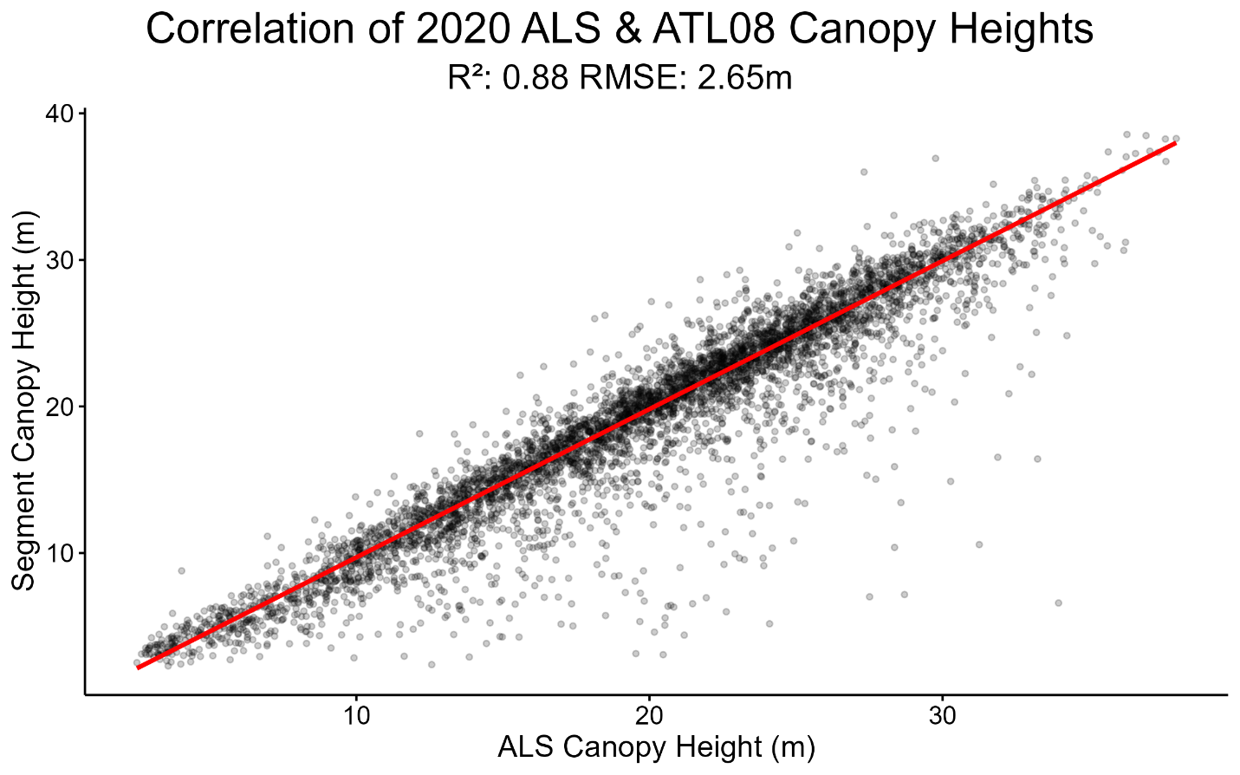

Figure 8: Correlation of canopy heights estimated by ALS (X) and ATL08 (Y), with each point in scatterplot corresponding to an individual ATL08 segment. Canopy heights are reported in meters above ground. Red line indicates trend line from a Theil-Sen regression.

* 1. **Study Area Homogeneity**
     1. **Sample Representation**

When comparing ALS canopy heights in the footprints of each sample against the population of ALS canopy heights across the study area, the samples appear representative of the broader forest population (Figure 9). The kernel density estimate of each sample’s canopy heights is in reasonable agreement with the overall population distribution. This suggests that ICESat-2 samples sufficiently capture the range of canopy heights across the study area, despite the spatial shift between samples. 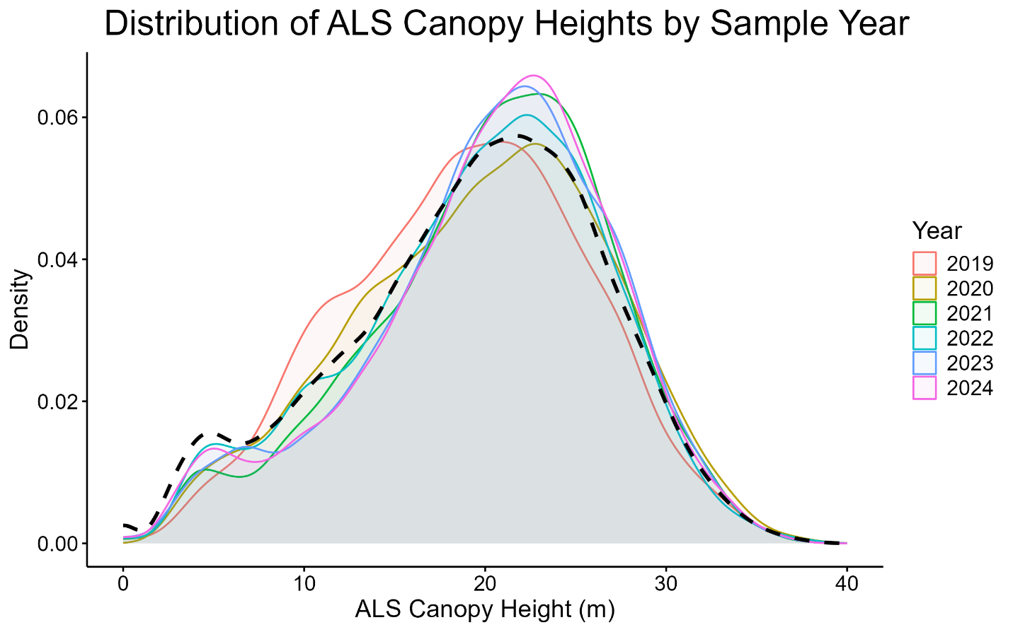

Figure 9: Representation of annual ATL08 samples. Plot shows kernel density estimates of ALS canopy heights within each annual ATL08 sample (colored distributions), overlaid on a kernel density estimate of the ALS canopy heights across the entire study area (dashed black line). Unique colors chosen for each sample’s kernel density estimate.

* + 1. **Sample Location Equivalence**

Bootstrapped TOST show that sample footprints are practically equivalent within a margin of two meters in canopy height (Figure 10). Below this margin, not all samples demonstrate equivalence with each other.

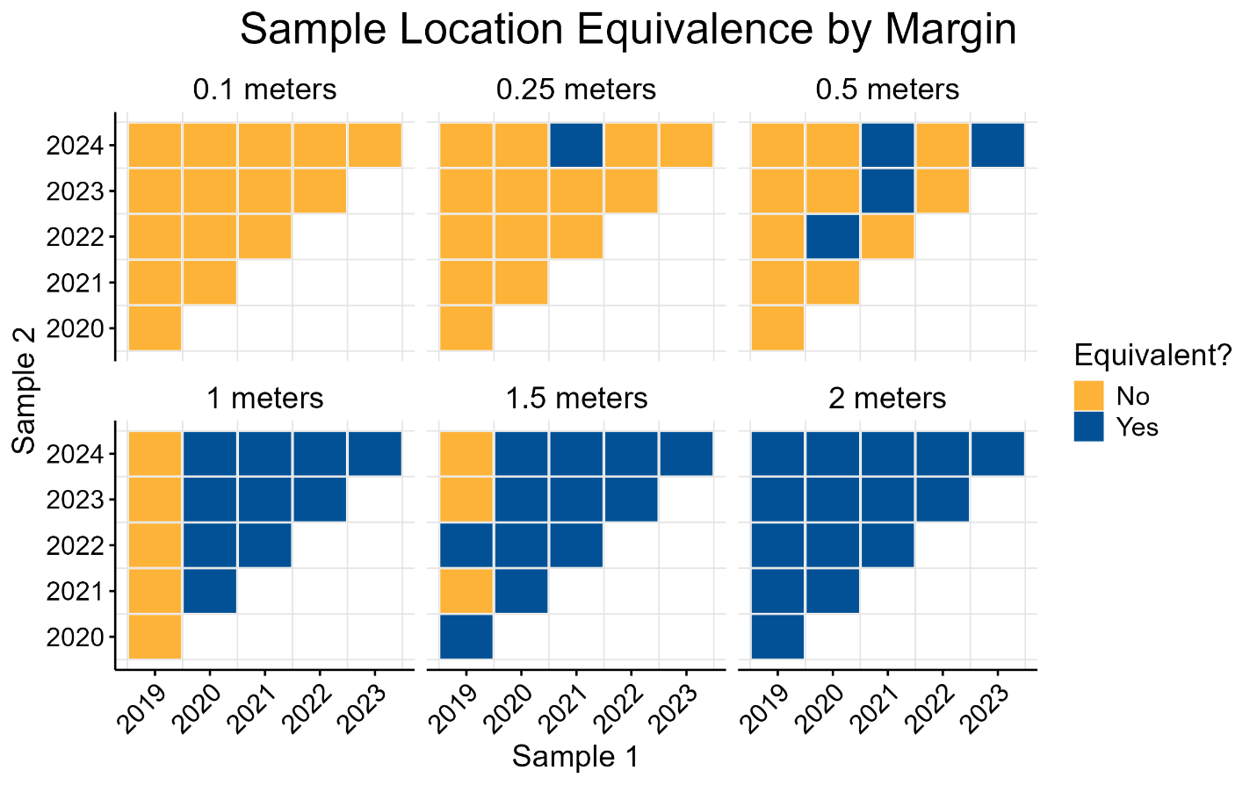

Figure 10: Grid of sample location equivalence across margin values, where each subplot represents a unique equivalence margin in meters. Within each subplot, cells indicate the result of an equivalence test comparing ALS canopy heights between Sample 1 (X) and Sample 2 (Y). Blue cells indicate practical equivalence within the specified margin. Yellow cells indicate non-equivalence, where at least one null hypothesis from the two one-sided tests was not rejected.

At a stricter equivalence margin of 0.1 meters, none of the samples demonstrate equivalence in canopy height. Based on the results in Figure 10, the 2019 sample demonstrates the lowest equivalence with other samples. This suggests that although this sample may be representative of the overall population, it contains spatial differences in canopy height with the other samples which could bias trends over time.

With this in mind, we remove the 2019 ATL08 sample from further analyses and all remaining samples (2020-2024) now demonstrate equivalence within a margin of 1 meter in canopy height. This minimizes the sampling bias present in our ATL08 segments, but limits the timeframe for tracking canopy height growth to only 5 years of data. As mentioned in section 2.4.3, we likewise filter NFI plots to only those with remeasurement periods of ~5 years to match the ATL08 data timeframe.

* 1. **Reference Growth**

Table 1 shows plot-level summary statistics for annual increment and net growth in tree height from NFI remeasurement plots.

Table 1: Summary statistics for NFI-derived increment and net growth in tree height. Units reported as original NFI measurements were in feet.

|  |  |  |  |  |  |  |  |
| --- | --- | --- | --- | --- | --- | --- | --- |
| **Variable** | **Units** | **Min.** | **Q1** | **Median** | **Mean** | **Q3** | **Max** |
| Increment | Meters per Year | 0 | 0.20 | 0.34 | 0.41 | 0.53 | 1.76 |
| Net Growth | Meters | 0 | 1.03 | 1.68 | 2.07 | 2.63 | 8.82 |

Figure 11 shows the distribution of height increment from remeasurement plots. The median value of 0.34 meters per year indicates expected plot-level annual tree height growth across the range of forest conditions in the study area.

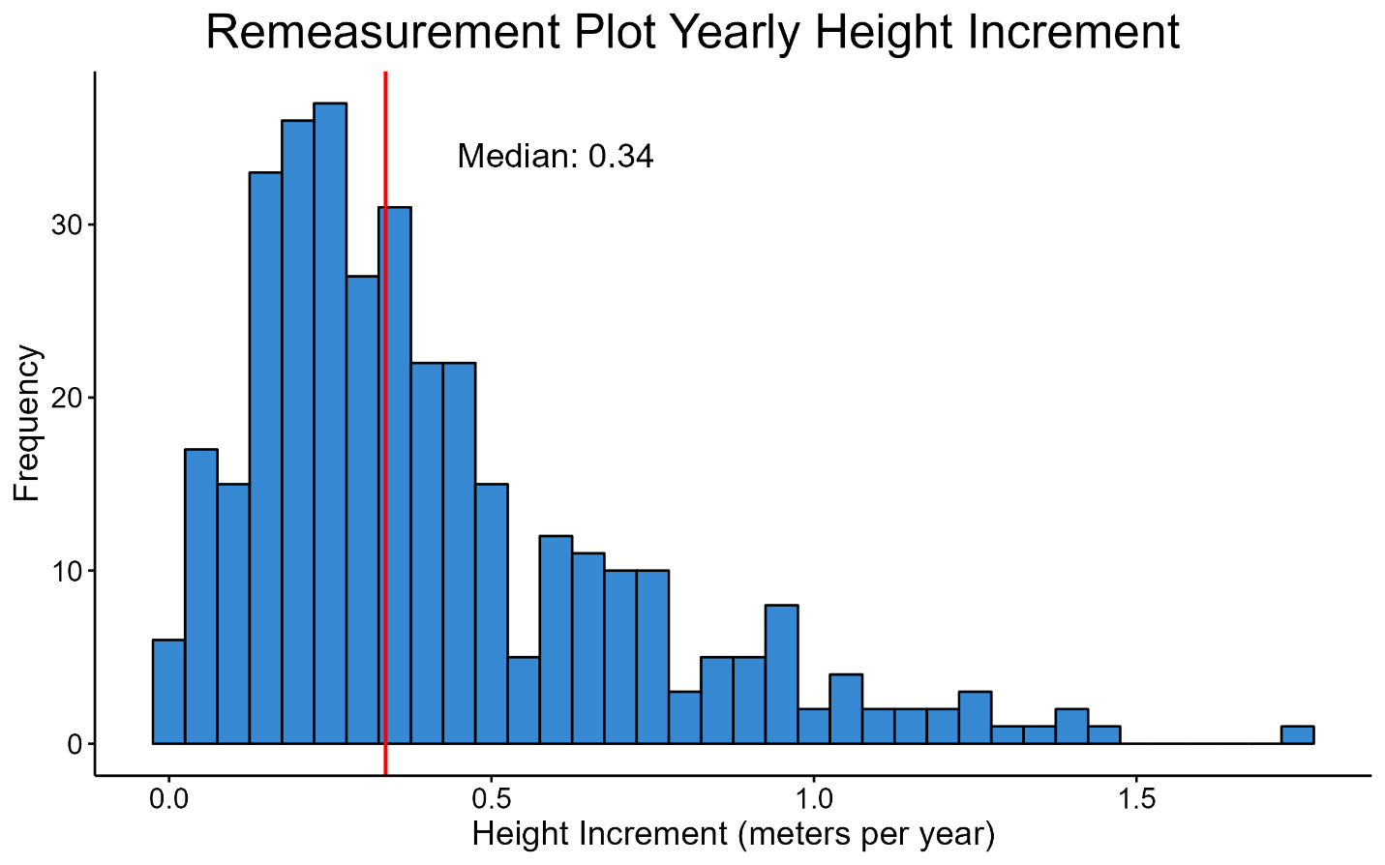

Figure 11: Distribution of NFI-derived tree height increment. Red line indicates median value.

Figure 12 shows the distribution of five-year net growth in tree height at the plot level. This distribution is centered at 1.68 meters with a strong right skew, indicating a most growth for most plots with some experiencing up to 8 meters of growth in a five-year period.

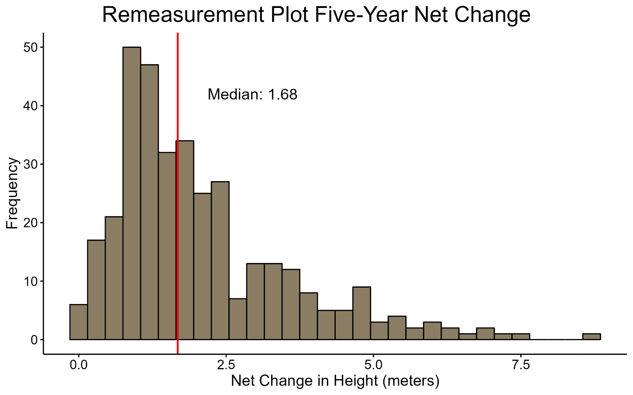

Figure 12: Distribution of NFI-derived five-year net growth in tree height. Red line indicates median value.

* 1. **ATL08-Derived Growth**

Wilcoxon Rank-Sum tests show statistically significant net growth in canopy height between 2020 and 2024 for all factor levels except forests with 20-30 years since disturbance (Figure 13a). The W statistic—indicating the summed ranks of canopy heights in the last year of data—is the highest in Woody Wetlands (W = 150,852.5) forest cover type. W values are comparable in disturbed (W = 147,100) and undisturbed (W = 146,066) forests. For forests with a disturbance history, W values are highest in the <10 years group (W = 154,561) and decrease moving away from disturbance in time.

The differences in median canopy height median the first and last year of data follow a similar pattern (Figure 13b). Of the forest cover types it is highest in Woody Wetlands, with a difference of 3.09 meters in five years. There is a slight separation between the differences for disturbed (2.42 m) and undisturbed (1.77 m) forests. The difference starts the highest in the <10 years group at 5.6 meters, and decreases moving away from disturbance in time until the 30+ years group, in which it increases to 2.91 meters.

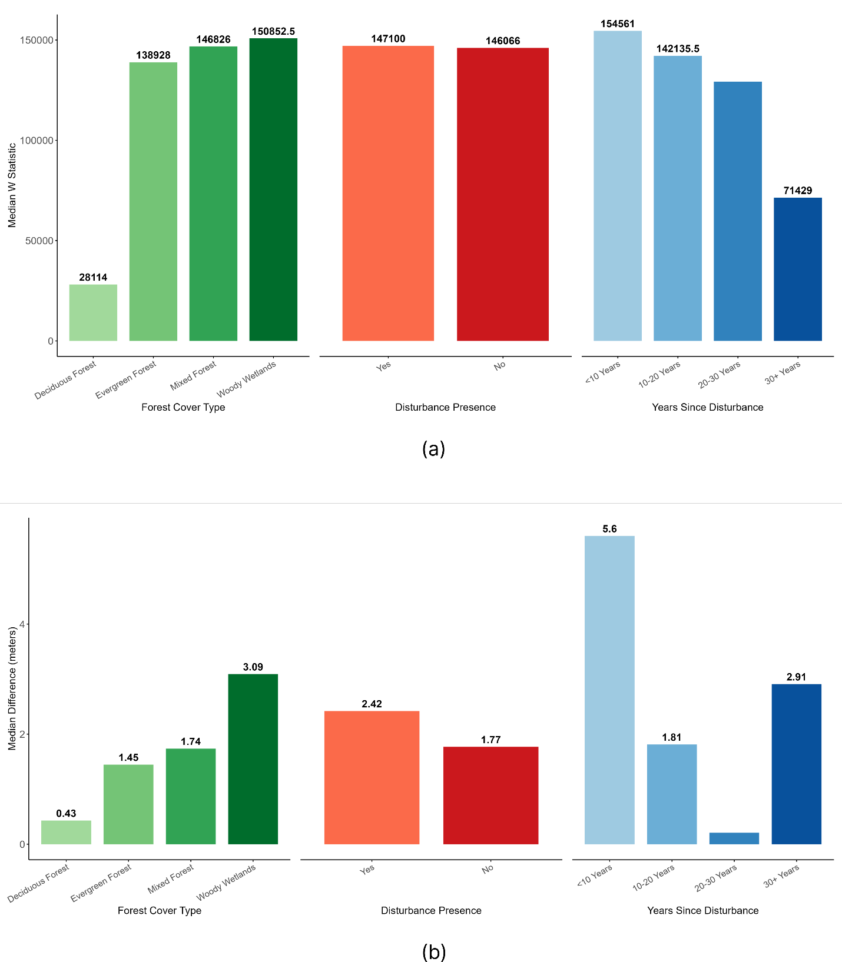

Figure 13: Results of ATL08 derived net growth in canopy height. Results grouped by factor and level, with separate plots showing a) the W statistic, and b) the difference in median canopy height between the first and last year of data. Bars with value labels indicate statistically significant trends (p < 0.05).

Theil-Sen regression models reveal statistically significant incremental canopy height growth for only four of ten factor levels (Figure 14). The highest estimated growth rate occurred in Woody Wetlands (0.43 m/year), followed by Evergreen Forest (0.42 m/year), Mixed Forest (0.40 m/year), and finally Deciduous Forest (0.30 m/year).

Disturbed forests show a higher growth rate (0.48 m/year) compared to undisturbed forests (0.37 m/year). For forests with a disturbance history, growth rates did not increase in tandem with time since disturbance. The highest rate was observed in forests disturbed <10 years ago (0.63 m/year), followed by lower rates in the 10-20 years (0.33 m/year) and 20-30 years (0.14 m/year) groups. Notably, the 30+ years group showed a rebound in growth rate of 0.55 m/year.

Trends for baseline canopy height differed from growth rates. Baseline canopy height is highest in Deciduous Forest (24.87 m), followed by Mixed Forest (24.17 m), Woody Wetlands (20.47 m), and is lowest in Evergreen Forest (19.91 m). Baseline canopy height was higher in undisturbed (23.59 m) forests than disturbed forests (18.71 m). For forests with a history of disturbance, baseline canopy height generally increased with time since disturbance.

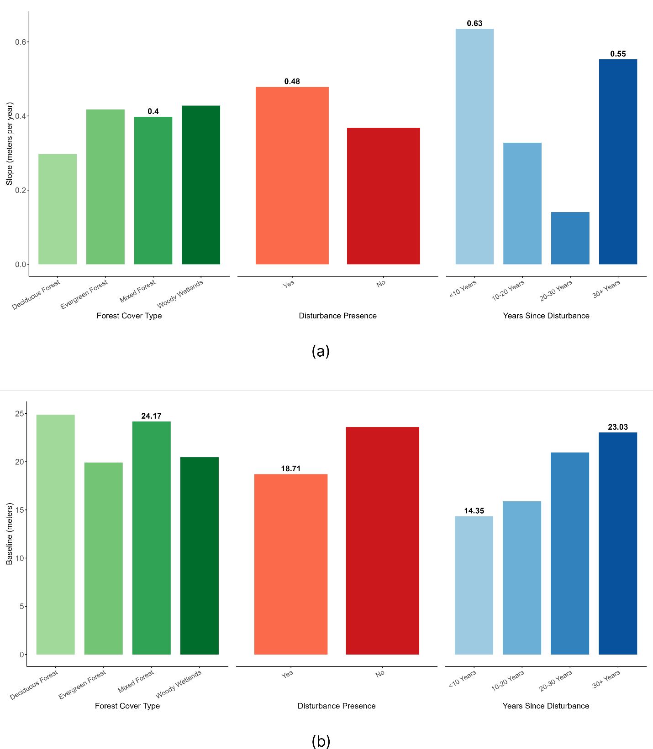

Figure 14: Results of ATL08-derived incremental growth in canopy height. Results grouped by factor and level, with separate plots showing a) the regression slope value, and b) the regression intercept values. Bars with value labels indicate statistically significant trends (p < 0.05).

Finally, MK tests show statistically significant monotonic growth in canopy height over time for six of ten factor levels (Figure 15). No significant trends were observed in Woody Wetlands, undisturbed forests, and forests disturbed 10-20 or 20-30 years ago. The Z value is the highest in Mixed Forests (Z = 2.53) of all forest cover types.

The Z value is higher in disturbed forests (Z = 1.98) than undisturbed forests (Z = 1.57), which showed no significant trend. For forests with a history of disturbance, Z values were high in areas disturbed <10 years ago (Z = 2.56), and decreased with time since disturbance. However, forests disturbed 30+ years ago showed the strongest trend of all factor levels (Z = 3.52).

Trends for Kendall’s Tau statistic mirror those of the Z statistic. Tau values range from 0.05 for Woody Wetlands, indicating the lowest agreement between canopy height growth and time, to 0.08 in Mixed Forests. Disturbed forests have a slightly higher tau (0.06) than undisturbed forests (0.05). Tau values are highest in forests with <10 or 30+ years since disturbance, compared to forests with more moderate time since disturbance.

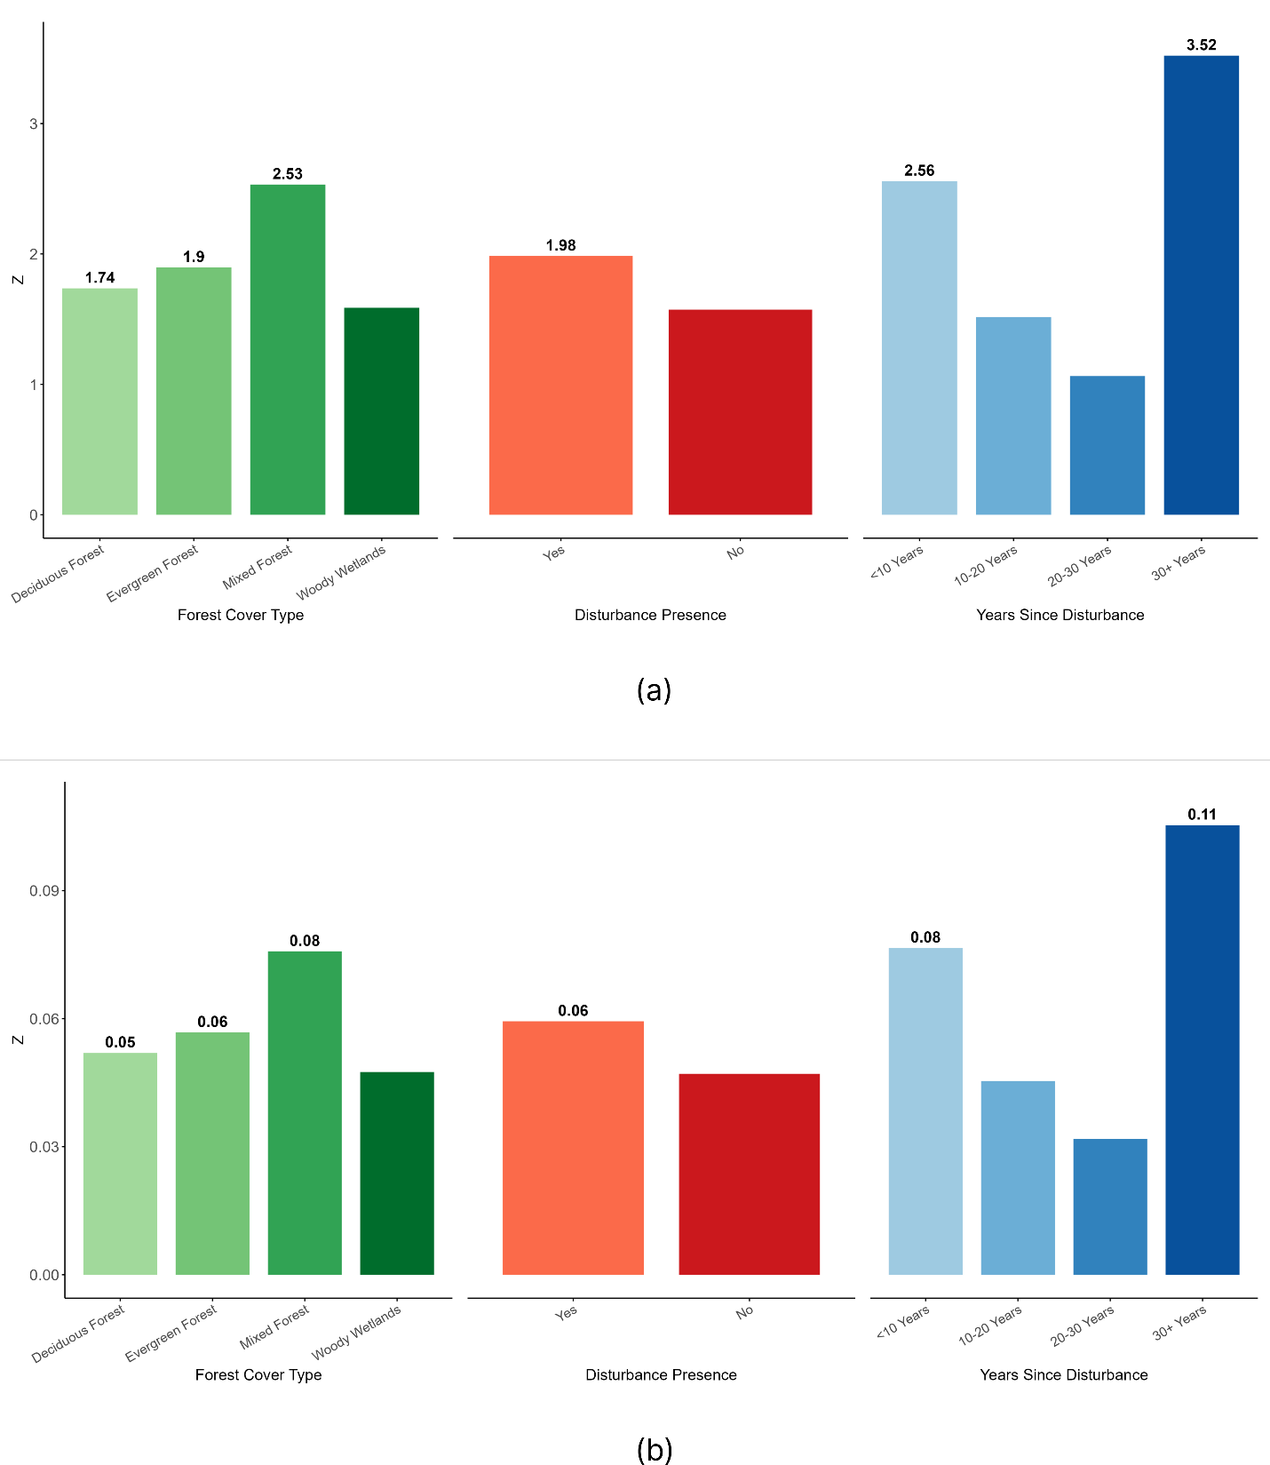

Figure 15: Results of ATL08-derived monotonic growth in canopy height. Results grouped by factor and level, with separate plots showing the a) Z statistic, and b) Tau statistic. Bars with value labels indicate statistically significant trends (p < 0.05).

1. **Discussion**

The ability of spaceborne LiDAR to reliably detect canopy height growth over time is vital for broad-scale forest monitoring, overcoming the temporal limitations of repeat ALS data acquisition and the spatial limitations of field inventories. However, the performance of ATL08 canopy height estimations can vary across a multitude of topographic, atmospheric, and ecological conditions. As such, any As such, any study utilizing ATL08 canopy height estimations must compare them against reference data sources.

We first demonstrated that ATL08 segments sufficiently estimate canopy heights within our study area (R2 = 0.88 , RMSE = 2.65) using coincident high-resolution ALS data. The minor underestimation of ATL08 canopy heights against reference ALS is noted in the literature (Neuenschwander et al., 2020; Rai et al., 2024; Yu et al., 2024). As posited in section 2.1, the strong performance of canopy height estimation by ATL08 segments was likely due to the consistent tree height and regular tree spacing of forest plantations present within the study area. Based on these results, ATL08 canopy height estimations in the study area at a single point in time were conducive for identifying trends throughout time.

We assessed the sampling bias present in ATL08 data by treating the footprints of each year of ATL08 segments as an individual sample of the landscape. Comparing the 2020 ALS in the footprints of each sample against the population of forests—the 2020 ALS across the entire study area—indicate that ATL08 segment locations provide representative samples. Comparing the samples against each other, all samples demonstrate practical equivalence within a margin of 2 meters in canopy height, showing a considerable level of agreement across a study area of over 5 million hectares. When tightening the equivalence margin to the 2019 sample did not demonstrate equivalence with the samples from 2021, 2023, or 2024, indicating some spatial difference in canopy height between the locations of those samples. Still, equivalence shown in 75% of groups within a 1.5-meter margin speaks to the forest cover homogeneity across the study area. After removing the 2019 sample, all samples demonstrate equivalence to each other within an even tighter 1-meter margin. Ultimately, the equivalence in canopy height between samples was deemed sufficient for our purposes, especially considering the RMSE of 2.64 meters in Phase 1, as it is unlikely that ATL08 measurements would be heavily influenced by spatial biases in canopy height falling within this margin of error.

NFI remeasurement plots established reference tree height growth within our study area. The distribution of height increment (Figure 11) is heavily concentrated in values below 0.5 meters per year, which may reflect maturing forests across the study area, as forest height growth and productivity slows as stands mature (Bennett, 1963; Tang et al., 2014). For loblolly pines vastly present throughout the southeastern United States (and therefore the study area), crown closure may occur within 10-20 years of age (Baker and Langdon, 1990; Bradley and Kush, 2019), leading to a reduced growth rate. While time since disturbance is not a direct proxy for stand age, ATL08 segments were primarily collected in forests with 10-20 (n = 9,478) and 20-30 (n = 8,003) years since disturbance, followed by forests with <10 years (7,462) and 30+ years (3,678) since disturbance.

**Add a sentence of the 8 meters of growth and how its gotta be an artefact, which is why we used histograms to see the skew.**

Dead trees were removed during NFI data processing to focus solely on living-tree growth. One can argue for retaining all standing trees to more holistically represent the forest structure surveyed by LiDAR, as ATL08 segments do not report tree status in canopy height estimations. However, including dead trees in NFI analyses would have lowered values of both increment and net growth. Dead trees were therefore removed from NFI remeasurement plots to select the best data subset to demonstrate forest height growth—just as the heavy filtering of ATL08 data aimed to achieve.

We used multiple statistical approaches to quantify net, incremental, and monotonic canopy height growth in ATL08 segment data. In revisiting the research questions, the results show that ATL08 segments *can* detect canopy height growth over a five-year period. The trends shown are specifically indicative of growth over time as the regression slope coefficients, Wilcoxon test mean differences, and Mann-Kendall Tau statistics are all positive. Net growth showed the most utility, with significant results present in nine of ten factor levels. Incremental and monotonic growth trends were likely subjected to the noise associated with ATL08 canopy height estimations, with significant results present in only four and six factor levels, respectively.

The role of forest cover type in ATL08-derived growth generally followed expectations. The highest rates of growth-indicated by regression slopes-were found in plantation-like conditions (Evergreen Forest and Woody Wetlands). Mixed Forests showed good agreement with reference NFI data, with a canopy height growth rate of 0.40 m/year matching closely with the NFI-derived annual increment of 0.34 m/year. Similarly the median difference of 1.74 meters in Mixed Forests aligned with the NFI-derived five-year net growth of 1.68 meters. This consistency was expected, as Mixed Forests provide a reasonable parallel to the breadth of forest conditions surveyed by the NFI. Limiting NFI remeasurement plots to only plantation-like conditions would have likely resulted in greater values for both annual increment and net growth, and closer alignment with the ATL08-derived trends of Evergreen Forests or Woody Wetlands.

The role of disturbance history had a more nuanced impact on the ATL08-derived growth, as disturbance histories are likely convolved within specific forest cover types. Forests that experienced disturbance <10 years ago demonstrated notably high values for the median difference (5.6 m) and growth rate (0.63 m/year). While these values may be subject to uncertainty from the inherent noise in ATL08 canopy height estimations, the significant growth across tests in this group suggests that the ATL08 segments are capturing a spike in forest growth immediately following disturbance events, such as heavy thins on forest plantations (Dickens and Moorhead, 2015). However, forests with 30+ years since disturbance also demonstrated significant growth across tests, with a five-year difference in median canopy height of 2.91 m, and the highest Z (3.51) and Tau (0.11) statistics of all factor levels. These results could be an artefact of the LCMS data product used to derive years since disturbance, as the comparable Global Forest Change product only extends back to the year 2000 in identifying forest change patterns (Hansen et al., 2013). Similarly, the divisions used to aggregate years since disturbance may have been too broad, with variability present in the 30+ years group driving the trends observed. However, aggregating years since disturbance in more granular periods would reduce the sample size of ATL08 segments falling within each. Ultimately, the disturbance history of forests will challenge future research estimating canopy height growth with ATL08 segments. Primarily, the sampling rate of the ATLAS instrument can lead to an amplified underestimation of canopy height in sparser stands, which have a lower probability of generating photon returns throughout the canopy profile. In comparison, a denser canopy with a more homogenous top surface—present in undisturbed forests, or plantations with ample recovery from disturbance—will generate a more accurate canopy height estimation. Vatandaslar et al. (2023) discuss this challenge to forest height estimation using airborne and spaceborne LiDAR, though it did not have a noticeable impact on their ATL08-derived results.   
 It should be noted the undeniable role of the study area in influencing the results, which was specifically chosen for its gentle topographic relief and known presence of forest plantations. In mountainous regions of greater terrain variability or tropical regions of greater canopy complexity, ATL08 canopy height estimations may contain greater error (Fernandez-Diaz et al., 2022; Liu et al., 2021). Moreover, our study area is located within the lolbolly pine range, a region noted for its exceptional forest productivity (Ribas-Costa et al., 2024).

This region undoubtedly provides canopy height growth greater than that to be expected in other U.S. forests, where growth patterns over five years may not reach a level detectable in ATL08 segment data. As such, we must note that researchers should strongly consider the dominant topography, forest conditions, and forest productivity of their study area if attempting to identify canopy height growth with ATL08 data.

Researchers must also consider the spatial scale of their study area. Ideally, a study area should be large enough to provide an ample set of ATL08 segments after data quality filters, but small enough to maintain consistency in forest conditions. In line with this idea of ecological consistency, the Environmental Protection Agency has outlined Ecoregions of the United States with similar geology, vegetation, climate, wildlife, etc. These Ecoregions are available at multiple scales of granularity, from the generalized Level I Ecoregions to the detailed Level IV Ecoregions. Figure 16 shows the proportion of ATL08 segments from each annual sample in the Level II Ecoregions found within our study area

**Ecoregion proportion plot here**

To effectively track growth over time, all annual samples should ideally share similar proportional coverage, regardless of whether the distribution between Ecoregions is 50:50, 75:25, 90:10, etc. In other words, the consistency in relative representation is more important than the balance between the Ecoregions themselves. Results of section 3.2.2 showed that the 2019 sample had the lowest canopy height equivalence with other samples, which led to its removal from further analyses. As shown in Figure 16, the 2019 sample also demonstrates the lowest similarity in its distribution across Level II Ecoregions with the other samples. When considering spatial scales best suited for forest monitoring with ATL08 data, this presents EPA Ecoregions as a possible recommendation to maintain a tight margin of canopy height equivalence across segment footprints.

Testing equivalence between treatments requires careful definition of a margin of “practical” equivalence—a range within treatment results are close enough to be considered the same in practice. In this research, this margin was the difference in canopy height between the footprints of annual samples we would tolerate when tracking growth over time. Ultimately, trends emerging from analyses of multitemporal ATL08 data will always be influenced by some spatial differences in forest height, purely due to the nature of ICESat-2’s sampling pattern. In absence of a widely accepted standard, researchers may derive their own definition of canopy height equivalence to balance the duration over which they’re assessing growth, the amount and spatial coverage of ATL08 data available, and the noise of ATL08 canopy height estimates within their study area. Since canopy height is emergent from multiple ecological factors and canopy height observations are limited by the precision of the measurement instrument, we found it appropriate to test equivalence across a range of equivalence margin values.

Other studies have used a flexible percentage-based approach for paired measurements of tree height, deeming a region within +25% of the slope and intercept means as practically equivalent (Corrao et al., 2022; Falkowski et al., 2008). While this research does not employ paired measurements for equivalence testing, a percentage-based approach could accommodate the range of forest cover types sampled by ICESat-2’s global coverage. A recent study by Guo et al. (2025) found equivalence for tree height measurements between instruments at a tolerance above 1.5 m in trees with a “pyramidal and well-defined crown”, much like those in pine plantations within our study area. While their study focused on measurement errors arising from degrees of field crew experience, an argument could be made that the numerous sources of error in ATL08 data present similar inconsistencies, despite our attempts to control them in this study.

1. **Conclusion**

**Acknowledgements**

**CRediT authorship contribution statement**

**Funding sources**

**Appendices**

1. **Statistical Approaches Used**

General descriptions for the statistical approaches used in this research are provided below. For further information, readers should refer to the references cited therein.

* 1. **Linear Regression Model**

Linear regression is a statistical method that represents the relationship between a dependent and explanatory variable by fitting a linear equation to the observations (Esri Inc., 2025). Linear regression employs an equation of the form:

$$Y=a+bX$$

Where *Y* is the dependent variable, *X* is the explanatory variable, *b* is the slope of the line, and *a* is the intercept (*Y* when *x* = 0). Linear regression is often performed using a least squares approach, where the fitted line attempts to minimize the sum of the squared residuals (*Linear Regression*, 1997). However, least squares approaches can be highly sensitive to outliers (Yu and Yao, 2017), a non-trivial issue in the context of canopy height estimation using LiDAR which may generate errant returns. The least squares estimation of a regression slope is ultimately a *weighted average* of pairwise slopes (Goldstein-Greenwood, 2023), and an extreme slope value between a data point and an outlier may strongly influence the slope estimate. As such, this research will employ a method of robust regression—the Theil-Sen regression (Sen, 1968; Theil, 1992). The Theil-Sen regression calculates the slope between a predictor and response variable as the *median* of slopes between each pair of points in the dataset, providing a correlation estimate that is less sensitive to outliers.

* 1. **Equivalence Test**

An insignificant p-value of a null-hypothesis test simply indicates the absence of evidence of a difference between treatments, which is not the same as stating equivalence between treatments (Altman and Bland, 1995). Failure in rejecting the null hypothesis does not automatically make it true, but merely shows insufficient evidence to support the alternate hypothesis (Wachs, 2015). More plainly, absence of evidence is not evidence of absence.

An equivalence test is a subtype of interval hypothesis testing which tests the null hypothesis that the difference between group means are larger than a margin of tolerable difference (Shtaynberger and Bar, 2023). Equivalence tests are used to show that group means are equivalent within a margin that is practically important, as it is never truly possible to show that an effect size (Δ) is zero (Lakens, 2022). As such, when reporting the results of an equivalence test it is common practice to report the equivalence margin the data is tested against.

This research will employ a two one-sided tests procedure for equivalence testing. In this procedure, the smallest effect size of interest is specified with an upper (ΔU) and lower (ΔL) bound of equivalence. Two one-sided tests utilize two composite null hypotheses (Lakens, 2017), following the formulas:

$$\begin{matrix}{H0}_{1}: Δ<-Δ_{L} \\ and \\ {H0}_{2}: Δ>Δ_{U}\end{matrix}$$

With this setup, we reject the presence of meaningful effects only if both tests yield values below 0.05 (Lakens, 2022), and consider the groups practically equivalent within the margin provided (JMP Statistical Discovery LLC, 2024).

* 1. **Wilcoxon Rank-Sum Test**

A t-test is a parametric test that evaluates the means of one or two populations. A one sample t-test compares a population’s mean against a known value, a two-sample t-test compares the means of two populations against each other, and a paired t-test compares paired measurements (JMP Statistical Discovery LLC, 2025). Given that this research aims to identify canopy height growth between sampled measurements, a two-sample t-test is appropriate. However, this research will employ a non-parametric alternative to the two-sample t-test— Wilcoxon Rank-Sum test. This test operates purely on the order (ranks) of observations the two samples, and the test statistic (W) is a sum of the ranks from one of the samples (Wild and Seber, 2000).

* 1. **Mann-Kendall Test**

The Mann-Kendall test is a non-parametric test used to assesses whether a time series has an upward or downward trend, and is flexible to accommodate missing values without requiring conformity to a specific distribution (Kendall and Gibbons, 1990; Mann, 1945; Meals et al., 2011). The test itself is rank-based and unaffected by the presence of extreme values in the dataset (Ringard et al., 2019). This makes it especially useful for time series of climatic data , as it can identify whether trends of perceived growth or decline are statistically significant despite fluctuations. The test statistic (S) is calculated with the equation:

$$S= \sum_{i=1}^{n-1}{\sum_{j=i+1}^{n}{sign(y_{j}-y_{i})}}$$

This equation determines the sign of the difference between each observation (*yj*) and the previous (*yi*), yielding a -1, 0, or 1 if the difference is negative, zero, or positive, respectively (EarthSoft, Inc., 2024). This statistic provides the number of increasing occurrences in the dataset, with larger, positive S values indicative of an upward trend over time. The Z value provides a practical look at the strength of the trend, calculated with:

$$Z= \frac{S±1}{\sqrt{V(s)}}$$

Where S – 1 is used if S > 0 or S + 1 is used if S < 0. If S = 0, Z is 0. More extreme Z values, whether negative or positive, provide greater confidence in rejecting the null hypothesis of no trend. Kendall’s Tau (τ) coefficient indicates the correlation of the observations and their order in time (Chen et al., 2022), with values ranging from -1 (negative correlation) to 1 (positive correlation)

* 1. **Bonferroni Correction**

In a single hypothesis test with a significance level of 0.05 the probability of a Type I error, or false positive, is 5%. However, when running multiple tests (a family), the Type I error rate increases considerably. In this research, we run 15 pairwise equivalence tests at each equivalence bound, increasing the family-wise error rate to 54% (Frost, 2023). By dividing the significance level by the total number of hypothesis tests performed, the Bonferroni controls the likelihood of a false positives (Amplitude, Inc., 2025). This correction yields a new significance level for our multiple hypothesis tests to be evaluated against.

**References**

Altman, D.G., Bland, J.M., 1995. Statistics Notes: Absence of Evidence Is Not Evidence of Absence. BMJ 311, 485–485. https://doi.org/10.1136/bmj.311.7003.485

Amplitude, Inc., 2025. Bonferroni Correction Explained: Managing Multiple Testing in Statistics. Prod. Web Exp. Artic. URL https://amplitude.com/explore/experiment/what-is-bonferroni-correction

Andersen, H.-E., Reutebuch, S.E., McGaughey, R.J., 2006. A Rigorous Assessment of Tree Height Measurements Obtained Using Airborne Lidar and Conventional Field Methods. Can. J. Remote Sens. 32, 355–366. https://doi.org/10.5589/m06-030

Anderson, J.R., Hardy, E.E., Roach, J.T., Witmer, R.E., 1976. A Land Use and Land Cover Classification System for Use with Remote Sensor Data, Professional Paper. US Geological Survey. https://doi.org/10.3133/pp964

Baker, J.B., Langdon, G.O., 1990. Pinus Taeda L. Loblolly Pine, in: Silvics of North America. U.S. Deptartment of Agriculture, Forest Service, Washington, D.C., pp. 497–512.

Bennett, F., 1963. Gorwth and Yield of Slash Pine Plantations (No. SE-1). U.S. Department of Agriculture, Forest Service Southern Forest Experiment Station, Asheville, N.

Bradley, S., Kush, J., 2019. Thinning Loblolly Pine Stands To Benefit Wildlife & Timber Production. Ala. Coop. Ext. Syst. URL https://www.aces.edu/blog/topics/forestry/thinning-loblolly-pine-stands-to-benefit-wildlife-timber-production/ (accessed 5.21.25).

Buchhorn, M., Smets, B., Bertels, L., Roo, B.D., Lesiv, M., Tsendbazar, N.-E., Herold, M., Fritz, S., 2020. Copernicus Global Land Service: Land Cover 100m: Collection 3: Epoch 2019: Globe. https://doi.org/10.5281/ZENODO.3939050

Burrill, E.A., DiTommaso, A.M., Turner, J.A., Pugh, S.A., Christensen, G., Kralicek, K.M., Perry, C.J., Lepine, L.C., Walker, D.M., Conkling, B.L., 2024. The Forest Inventory and Analysis Database, FIADB User Guides. U.S. Department of Agriculture, Forest Service.

Caldwell, A.R., 2025. Robust TOST Procedures (Vigenette).

Caldwell, A.R., 2022. Exploring Equivalence Testing with the Updated TOSTER R Package. https://doi.org/10.31234/osf.io/ty8de

Callaghan, J., 2020. Extreme Rainfall and Flooding from Hurricane Florence. Trop. Cyclone Res. Rev. 9, 172–177. https://doi.org/10.1016/j.tcrr.2020.07.002

Cao, L., Coops, N.C., Innes, J.L., Sheppard, S.R.J., Fu, L., Ruan, H., She, G., 2016. Estimation of Forest Biomass Dynamics in Subtropical Forests Using Multi-Temporal Airborne LiDAR Data. Remote Sens. Environ. 178, 158–171. https://doi.org/10.1016/j.rse.2016.03.012

Carabajal, C.C., Boy, J.-P., 2020. ICESat-2 Altimetry as Geodetic Control. Int. Arch. Photogramm. Remote Sens. Spat. Inf. Sci. XLIII-B3-2020, 1299–1306. https://doi.org/10.5194/isprs-archives-XLIII-B3-2020-1299-2020

Chen, F., Zhang, X., Wang, Longyu, Du, B., Dang, S., Wang, Linwei, 2023. Systematic Evaluation of Multi-Resolution ICESat-2 Canopy Height Data: A Case Study of the Taranaki Region. Remote Sens. 15, 5686. https://doi.org/10.3390/rs15245686

Chen, S., Ghadami, A., Epureanu, B.I., 2022. Practical Guide to Using Kendall’s Tau in the Context of Forecasting Critical Transitions. R. Soc. Open Sci. 9, 211346. https://doi.org/10.1098/rsos.211346

Coops, N.C., Tompalski, P., Goodbody, T.R.H., Queinnec, M., Luther, J.E., Bolton, D.K., White, J.C., Wulder, M.A., Van Lier, O.R., Hermosilla, T., 2021. Modelling LiDAR-Derived Estimates of Forest Attributes Over Space and Time: A Review of Approaches and Future Trends. Remote Sens. Environ. 260, 112477. https://doi.org/10.1016/j.rse.2021.112477

Corrao, M.V., Sparks, A.M., Smith, A.M.S., 2022. A Conventional Cruise and Felled-Tree Validation of Individual Tree Diameter, Height and Volume Derived from Airborne Laser Scanning Data of a Loblolly Pine (p. Taeda) Stand in Eastern Texas. Remote Sens. 14, 2567. https://doi.org/10.3390/rs14112567

Dickens, E.D., Moorhead, D.J., 2015. A Guide to Thinning Pine Plantations. Ga. For. Product. 0010.

Dubayah, R., Armston, J., Healey, S.P., Bruening, J.M., Patterson, P.L., Kellner, J.R., Duncanson, L., Saarela, S., Ståhl, G., Yang, Z., Tang, H., Blair, J.B., Fatoyinbo, L., Goetz, S., Hancock, S., Hansen, M., Hofton, M., Hurtt, G., Luthcke, S., 2022. GEDI Launches a New Era of Biomass Inference from Space. Environ. Res. Lett. 17, 095001. https://doi.org/10.1088/1748-9326/ac8694

Dubayah, R., Blair, J.B., Goetz, S., Fatoyinbo, L., Hansen, M., Healey, S., Hofton, M., Hurtt, G., Kellner, J., Luthcke, S., Armston, J., Tang, H., Duncanson, L., Hancock, S., Jantz, P., Marselis, S., Patterson, P.L., Qi, W., Silva, C., 2020. The Global Ecosystem Dynamics Investigation: High-Resolution Laser Ranging of the Earth’s Forests and Topography. Sci. Remote Sens. 1, 100002. https://doi.org/10.1016/j.srs.2020.100002

EarthSoft, Inc., 2024. Mann-Kendall Tests [WWW Document]. EQuIS 7243. URL https://help.earthsoft.com/lib_mann-kendall.htm (accessed 5.19.25).

Esri Inc., 2025. How Linear Regression Algorithm Works. Feature Tabular Anal. Toolset Concepts. URL https://pro.arcgis.com/en/pro-app/latest/tool-reference/geoai/how-linear-regression-works.htm

Esri Inc., 2024. ArcGIS Pro.

Falkowski, M.J., Smith, A.M.S., Gessler, P.E., Hudak, A.T., Vierling, L.A., Evans, J.S., 2008. The Influence of Conifer Forest Canopy Cover on the Accuracy of Two Individual Tree Measurement Algorithms Using LiDAR Data. Can. J. Remote Sens. 34, S338–S350. https://doi.org/10.5589/m08-055

FAO and UNEP, 2020. The State of the World’s Forests 2020, Forests, biodiversity, and people. FAO and UNEP, Rome. https://doi.org/10.4060/ca8642en

Feng, T., Duncanson, L., Montesano, P., Hancock, S., Minor, D., Guenther, E., Neuenschwander, A., 2023. A Systematic Evaluation of Multi-Resolution ICESat-2 ATL08 Terrain and Canopy Heights in Boreal Forests. Remote Sens. Environ. 291, 113570. https://doi.org/10.1016/j.rse.2023.113570

Fernandez-Diaz, J.C., Velikova, M., Glennie, C.L., 2022. Validation of ICESat-2 ATL08 Terrain and Canopy Height Retrievals in Tropical Mesoamerican Forests. IEEE J. Sel. Top. Appl. Earth Obs. Remote Sens. 15, 2956–2970. https://doi.org/10.1109/JSTARS.2022.3163208

Frost, J., 2023. What is the Bonferroni Correction and How to Use It. Stat. Jim. URL https://statisticsbyjim.com/hypothesis-testing/bonferroni-correction/

Goldstein-Greenwood, J., 2023. Theil-Sen Regression: Programming and Understanding an Outlier-Resistant Alternative to Least Squares. UVA Libr. StatLab.

Griffin, M., Malsick, M., Mizzell, H., Moore, L., 2020. Historic Rainfall and Record-Breaking Flooding from Hurricane Florence in the Pee Dee Watershed. J. S. C. Water Resour. 28–35. https://doi.org/10.34068/JSCWR.06.03

Guerra-Hernández, J., Arellano-Pérez, S., González-Ferreiro, E., Pascual, A., Sandoval Altelarrea, V., Ruiz-González, A.D., Álvarez-González, J.G., 2021. Developing a Site Index Model for P. Pinaster Stands in NW Spain by Combining Bi-Temporal ALS Data and Environmental Data. For. Ecol. Manag. 481, 118690. https://doi.org/10.1016/j.foreco.2020.118690

Guerra-Hernández, J., Narine, L.L., Pascual, A., Gonzalez-Ferreiro, E., Botequim, B., Malambo, L., Neuenschwander, A., Popescu, S.C., Godinho, S., 2022. Aboveground Biomass Mapping by Integrating ICESat-2, Sentinel-1, Sentinel-2, ALOS2/PALSAR2, and Topographic Information in Mediterranean Forests. GIScience Remote Sens. 59, 1509–1533. https://doi.org/10.1080/15481603.2022.2115599

Hancock, S., McGrath, C., Lowe, C., Davenport, I., Woodhouse, I., 2021. Requirements for a Global Lidar System: Spaceborne Lidar with Wall-to-Wall Coverage. R. Soc. Open Sci. 8, 211166. https://doi.org/10.1098/rsos.211166

Hansen, M.C., Potapov, P.V., Moore, R., Hancher, M., Turubanova, S.A., Tyukavina, A., Thau, D., Stehman, S.V., Goetz, S.J., Loveland, T.R., Kommareddy, A., Egorov, A., Chini, L., Justice, C.O., Townshend, J.R.G., 2013. High-Resolution Global Maps of 21st-Century Forest Cover Change. Science 342, 850–853. https://doi.org/10.1126/science.1244693

Harris, N., Gibbs, D., 2021. Forests Absorb Twice As Much Carbon As They Emit Each Year.

Hinck, J.E., Stachyra, J., 2019. 2019 Disaster Relief Act: USGS Recovery Activities (USGS Numbered Series No. 2019–3066), Fact Sheet. Columbia Environmental Research Center, U.S. Geological Survey, Reston, VA.

Hobu, Inc., 2025. USGS 3DEP LiDAR Point Clouds.

Housman, I.W., Heyer, J.P., Hardwick, E.A., Leatherman, L., Beck, H., Lecker, J., Megown, K., Ross, J., 2024. Forest Service Landscape Change Monitoring System Methods (GTAC-10252- RPT4 No. Version 2023.9). U.S. Department of Agriculture, Forest Service, Geospatial Technology and Applications Center, Salt Lake City, UT.

Hurtado, S.L., 2020. RobustLinearReg: Robust Linear Regressions. https://doi.org/10.32614/CRAN.package.RobustLinearReg

Jarron, L.R., Coops, N.C., MacKenzie, W.H., Tompalski, P., Dykstra, P., 2020. Detection of Sub-Canopy Forest Structure Using Airborne LiDAR. Remote Sens. Environ. 244, 111770. https://doi.org/10.1016/j.rse.2020.111770

JMP Statistical Discovery LLC, 2025. The T-Test [WWW Document]. Stat. Knowl. Portal. URL https://www.jmp.com/en/statistics-knowledge-portal/t-test

JMP Statistical Discovery LLC, 2024. Equivalence Test Reports [WWW Document]. URL https://www.jmp.com/support/help/en/18.1/index.shtml#page/jmp/equivalence-test-reports.shtml

Jordahl, K., Bossche, J.V.D., Fleischmann, M., Wasserman, J., McBride, J., Gerard, J., Tratner, J., Perry, M., Badaracco, A.G., Farmer, C., Hjelle, G.A., Snow, A.D., Cochran, M., Gillies, S., Culbertson, L., Bartos, M., Eubank, N., Maxalbert, Bilogur, A., Rey, S., Ren, C., Arribas-Bel, D., Wasser, L., Wolf, L.J., Journois, M., Wilson, J., Greenhall, A., Holdgraf, C., Filipe, Leblanc, F., 2020. geopandas/geopandas: v0.8.1. https://doi.org/10.5281/ZENODO.3946761

Kendall, M.G., Gibbons, J.D., 1990. Rank correlation methods, 5. ed. ed. Oxford Univ. Press, New York.

Khaine, I., Woo, S.Y., 2015. An Overview of Interrelationship Between Climate Change and Forests. For. Sci. Technol. 11, 11–18. https://doi.org/10.1080/21580103.2014.932718

Klotz, B.W., Neuenschwander, A., Magruder, L.A., 2020. High‐Resolution Ocean Wave and Wind Characteristics Determined by the ICESat‐2 Land Surface Algorithm. Geophys. Res. Lett. 47. https://doi.org/10.1029/2019gl085907

Lakens, D., 2022. Improving Your Statistical Inferences. https://doi.org/10.5281/ZENODO.6409077

Lakens, D., 2017. Equivalence Tests: A Practical Primer for t-Tests, Correlations, and Meta-Analyses. Soc. Psychol. Personal. Sci. 8, 355–362. https://doi.org/10.1177/1948550617697177

LANDFIRE, Earth Resources Observation and Science Center (EROS), U.S. Geological Survey, 2022a. LANDFIRE 2020 Aspect (Asp) CONUS.

LANDFIRE, Earth Resources Observation and Science Center (EROS), U.S. Geological Survey, 2022b. LANDFIRE 2020 Elevation (Elev) CONUS.

LaRue, E.A., Fahey, R., Fuson, T.L., Foster, J.R., Matthes, J.H., Krause, K., Hardiman, B.S., 2022. Evaluating the Sensitivity of Forest Structural Diversity Characterization to LiDAR Point Density. Ecosphere 13, e4209. https://doi.org/10.1002/ecs2.4209

Li, B., Zhao, T., Su, X., Fan, G., Zhang, W., Deng, Z., Yu, Y., 2022. Correction of Terrain Effects on Forest Canopy Height Estimation Using ICESat-2 and High Spatial Resolution Images. Remote Sens. 14, 4453. https://doi.org/10.3390/rs14184453

Li, W., Niu, Z., Shang, R., Qin, Y., Wang, L., Chen, H., 2020. High-Resolution Mapping of Forest Canopy Height Using Machine Learning by Coupling ICESat-2 LiDAR with Sentinel-1, Sentinel-2 and Landsat-8 Data. Int. J. Appl. Earth Obs. Geoinformation 92, 102163. https://doi.org/10.1016/j.jag.2020.102163

Linear Regression (No. 101), 1997. , Course List for 1997-98. Department of Statistics, Yale University.

Liu, A., Cheng, X., Chen, Z., 2021. Performance Evaluation of GEDI and ICESat-2 Laser Altimeter Data for Terrain and Canopy Height Retrievals. Remote Sens. Environ. 264, 112571. https://doi.org/10.1016/j.rse.2021.112571

Liu, M., Popescu, S., Malambo, L., 2019. Feasibility of Burned Area Mapping Based on ICESAT−2 Photon Counting Data. Remote Sens. 12, 24. https://doi.org/10.3390/rs12010024

Luthcke, S.B., Thomas, T.C., Pennington, T.A., Rebold, T.W., Nicholas, J.B., Rowlands, D.D., Gardner, A.S., Bae, S., 2021. ICESat‐2 Pointing Calibration and Geolocation Performance. Earth Space Sci. 8, e2020EA001494. https://doi.org/10.1029/2020EA001494

Malambo, L., Popescu, S., 2024. Mapping Vegetation Canopy Height Across the Contiguous United States Using ICESat-2 and Ancillary Datasets. Remote Sens. Environ. 309, 114226. https://doi.org/10.1016/j.rse.2024.114226

Malambo, L., Popescu, S.C., 2021. Assessing the Agreement of ICESat-2 Terrain and Canopy Height with Airborne Lidar Over US Ecozones. Remote Sens. Environ. 266, 112711. https://doi.org/10.1016/j.rse.2021.112711

Maltamo, M., Næsset, E., Vauhkonen, J. (Eds.), 2014. Forestry Applications of Airborne Laser Scanning: Concepts and Case Studies, Managing Forest Ecosystems. Springer Netherlands, Dordrecht. https://doi.org/10.1007/978-94-017-8663-8

Mann, H.B., 1945. Nonparametric Tests Against Trend. Econometrica 13, 245. https://doi.org/10.2307/1907187

Markus, T., Neumann, T., Martino, A., Abdalati, W., Brunt, K., Csatho, B., Farrell, S., Fricker, H., Gardner, A., Harding, D., Jasinski, M., Kwok, R., Magruder, L., Lubin, D., Luthcke, S., Morison, J., Nelson, R., Neuenschwander, A., Palm, S., Popescu, S., Shum, C., Schutz, B.E., Smith, B., Yang, Y., Zwally, J., 2017. The Ice, Cloud, and Land Elevation Satellite-2 (ICESat-2): Science Requirements, Concept, and Implementation. Remote Sens. Environ. 190, 260–273. https://doi.org/10.1016/j.rse.2016.12.029

Meals, D., Spooner, J., Dressing, S., Harcum, J., 2011. Statistical Analysis for Monotonic Trends (No. 6), Tech Notes. U.S. Environmental Protection Agency, Fairfax, VA.

Mielcarek, M., Kamińska, A., Stereńczak, K., 2020. Digital Aerial Photogrammetry (DAP) and Airborne Laser Scanning (ALS) as Sources of Information About Tree Height: Comparisons of the Accuracy of Remote Sensing Methods for Tree Height Estimation. Remote Sens. 12, 1808. https://doi.org/10.3390/rs12111808

Mitchell, J.C., Kashian, D.M., Chen, X., Cousins, S., Flaspohler, D., Gruner, D.S., Johnson, J.S., Surasinghe, T.D., Zambrano, J., Buma, B., 2023. Forest Ecosystem Properties Emerge from Interactions of Structure and Disturbance. Front. Ecol. Environ. 21, 14–23. https://doi.org/10.1002/fee.2589

Mulverhill, C., Coops, N.C., Hermosilla, T., White, J.C., Wulder, M.A., 2022. Evaluating ICESat-2 for Monitoring, Modeling, and Update of Large Area Forest Canopy Height Products. Remote Sens. Environ. 271, 112919. https://doi.org/10.1016/j.rse.2022.112919

Neuenschwander, A., Duncanson, L., Montesano, P., Minor, D., Guenther, E., Hancock, S., Wulder, M.A., White, J.C., Purslow, M., Thomas, N., Mandel, A., Feng, T., Armston, J., Kellner, J.R., Andersen, H.E., Boschetti, L., Fekety, P., Hudak, A., Pisek, J., Sánchez-López, N., Stereńczak, K., 2024. Towards Global Spaceborne LiDAR Biomass: Developing and Applying Boreal Forest Biomass Models for ICESat-2 Laser Altimetry Data. Sci. Remote Sens. 10, 100150. https://doi.org/10.1016/j.srs.2024.100150

Neuenschwander, A., Guenther, E., White, J.C., Duncanson, L., Montesano, P., 2020. Validation of ICESat-2 Terrain and Canopy Heights in Boreal Forests. Remote Sens. Environ. 251, 112110. https://doi.org/10.1016/j.rse.2020.112110

Neuenschwander, A., Magruder, L.A., 2019. Canopy and Terrain Height Retrievals with ICESat-2: A First Look. Remote Sens. 11, 1721. https://doi.org/10.3390/rs11141721

Neuenschwander, A., Pitts, K., 2019. The ATL08 Land and Vegetation Product for the ICESat-2 Mission. Remote Sens. Environ. 221, 247–259. https://doi.org/10.1016/j.rse.2018.11.005

Neuenschwander, A., Pitts, K., Jelley, B.J., Robbins, J., Markel, J., Popescu, S., Nelson, R., Harding, D., Pederson, Klotz, B., Sheridan, R., 2023. Ice, Cloud, and Land Elevation Satellite (ICESat-2) Project Algorithm Theoretical Basis Document (ATBD) for Land - Vegetation Along-Track Products (ATL08), version 6. https://doi.org/10.5067/8ANPSL1NN7YS

Neumann, T.A., Brenner, A., Hancock, D., Robins, J., Saba, J., Harbeck, K., Gibbons, A., Lee, J., Luthcke, S., Rebold, T., 2023. Ice, Cloud, and Land Elevation Satellite (ICESat-2) Project Algorithm Theoretical Basis Document (ATBD) for Global Geolocated Photons ATL03, version 6. https://doi.org/10.5067/GA5KCLJT7LOT

Neumann, T.A., Martino, A.J., Markus, T., Bae, S., Bock, M.R., Brenner, A.C., Brunt, K.M., Cavanaugh, J., Fernandes, S.T., Hancock, D.W., Harbeck, K., Lee, J., Kurtz, N.T., Luers, P.J., Luthcke, S.B., Magruder, L., Pennington, T.A., Ramos-Izquierdo, L., Rebold, T., Skoog, J., Thomas, T.C., 2019. The Ice, Cloud, and Land Elevation Satellite – 2 Mission: A Global Geolocated Photon Product Derived from the Advanced Topographic Laser Altimeter System. Remote Sens. Environ. 233, 111325. https://doi.org/10.1016/j.rse.2019.111325

Oh, S., Jung, J., Shao, Guofan, Shao, Gang, Gallion, J., Fei, S., 2022. High-Resolution Canopy Height Model Generation and Validation Using USGS 3DEP LiDAR Data in Indiana, USA. Remote Sens. 14, 935. https://doi.org/10.3390/rs14040935

Paul, S., Ghebreyesus, D., Sharif, H.O., 2019. Brief Communication: Analysis of the Fatalities and Socio-Economic Impacts Caused by Hurricane Florence. Geosciences 9, 58. https://doi.org/10.3390/geosciences9020058

PDAL Contributors, 2025. PDAL Point Data Abstraction Library.

Pingel, T.J., Clarke, K.C., McBride, W.A., 2013. An Improved Simple Morphological Filter for the Terrain Classification of Airborne LiDAR Data. ISPRS J. Photogramm. Remote Sens. 77, 21–30. https://doi.org/10.1016/j.isprsjprs.2012.12.002

Pronk, M., Eleveld, M., Ledoux, H., 2024. Assessing Vertical Accuracy and Spatial Coverage of ICESat-2 and GEDI Spaceborne Lidar for Creating Global Terrain Models. Remote Sens. 16, 2259. https://doi.org/10.3390/rs16132259

Psistaki, K., Tsantopoulos, G., Paschalidou, A., 2024. An Overview of the Role of Forests in Climate Change Mitigation. Sustainability 16. https://doi.org/10.3390/su16146089

R Core Team, 2023. R: A Language for Statistical Computing.

Radtke, P., 2025. FIADB_Direct.

Rai, N., Ma, Q., Poudel, K.P., Himes, A., Meng, Q., 2024. Evaluating the Uncertainties in Forest Canopy Height Measurements Using ICESat-2 Data. J. Remote Sens. 4, 0160. https://doi.org/10.34133/remotesensing.0160

Renwick, K., 2023. 2022 Forest Inventory and Analysis Business Report (Business Report). U.S. Department of Agriculture, Forest Service, Research and Development, Forest Inventory and Analysis Program, Washington, D.C.

Ribas-Costa, V.A., Gastón, A., Cook, R.L., 2024. Modeling Dominant Height with USGS 3DEP LiDAR to Determine Site Index in Even-Aged Loblolly Pine (Pinus Taeda L.) Plantations in the Southeastern Us. For. Int. J. For. Res. cpae034. https://doi.org/10.1093/forestry/cpae034

Ringard, J., Chiriaco, M., Bastin, S., Habets, F., 2019. Recent Trends in Climate Variability at the Local Scale Using 40 Years of Observations: The Case of the Paris Region of France. Atmospheric Chem. Phys. 19, 13129–13155. https://doi.org/10.5194/acp-19-13129-2019

Roberts, S.D., Dean, T.J., Evans, D.L., McCombs, J.W., Harrington, R.L., Glass, P.A., 2005. Estimating Individual Tree Leaf Area in Loblolly Pine Plantations Using LiDAR-Derived Measurements of Height and Crown Dimensions. For. Ecol. Manag. 213, 54–70. https://doi.org/10.1016/j.foreco.2005.03.025

Rossum, G. van, Drake, F.L., 2010. The Python language reference, Release 3.0.1 [Repr.]. ed, Python documentation manual / Guido van Rossum; Fred L. Drake [ed.]. Python Software Foundation, Hampton, NH.

Schutz, B.E., Zwally, H.J., Shuman, C.A., Hancock, D., DiMarzio, J.P., 2005. Overview of the ICESat Mission. Geophys. Res. Lett. 32, 2005GL024009. https://doi.org/10.1029/2005GL024009

Seidl, R., Thom, D., Kautz, M., Martin-Benito, D., Peltoniemi, M., Vacchiano, G., Wild, J., Ascoli, D., Petr, M., Honkaniemi, J., Lexer, M.J., Trotsiuk, V., Mairota, P., Svoboda, M., Fabrika, M., Nagel, T.A., Reyer, C.P.O., 2017. Forest Disturbances Under Climate Change. Nat. Clim. Change 7, 395–402. https://doi.org/10.1038/nclimate3303

Sen, P.K., 1968. Estimates of the Regression Coefficient Based on Kendall’s Tau. J. Am. Stat. Assoc. 63, 1379–1389. https://doi.org/10.1080/01621459.1968.10480934

Shtaynberger, J., Bar, H., 2023. Equivalence Testing. Cornell Statistical Consulting Unit.

Socha, J., Hawryło, P., Stereńczak, K., Miścicki, S., Tymińska-Czabańska, L., Młocek, W., Gruba, P., 2020. Assessing the Sensitivity of Site Index Models Developed Using Bi-Temporal Airborne Laser Scanning Data to Different Top Height Estimates and Grid Cell Sizes. Int. J. Appl. Earth Obs. Geoinformation 91, 102129. https://doi.org/10.1016/j.jag.2020.102129

Sumnall, M.J., Albaugh, T.J., Carter, D.R., Cook, R.L., Hession, W.C., Campoe, O.C., Rubilar, R.A., Wynne, R.H., Thomas, V.A., 2022. Effect of Varied Unmanned Aerial Vehicle Laser Scanning Pulse Density on Accurately Quantifying Forest Structure. Int. J. Remote Sens. 43, 721–750. https://doi.org/10.1080/01431161.2021.2023229

Sun, T., Qi, J., Huang, H., 2020. Discovering Forest Height Changes Based on Spaceborne Lidar Data of ICESat-1 in 2005 and ICESat-2 in 2019: A Case Study in the Beijing-Tianjin-Hebei Region of China. For. Ecosyst. 7, 53. https://doi.org/10.1186/s40663-020-00265-w

Tang, J., Luyssaert, S., Richardson, A.D., Kutsch, W., Janssens, I.A., 2014. Steeper Declines in Forest Photosynthesis Than Respiration Explain Age-Driven Decreases in Forest Growth. Proc. Natl. Acad. Sci. 111, 8856–8860. https://doi.org/10.1073/pnas.1320761111

The pandas development team, 2025. pandas-dev/pandas: Pandas. https://doi.org/10.5281/ZENODO.15831829

Theil, H., 1992. A Rank-Invariant Method of Linear and Polynomial Regression Analysis, in: Raj, B., Koerts, J. (Eds.), Henri Theil’s Contributions to Economics and Econometrics, Advanced Studies in Theoretical and Applied Econometrics. Springer Netherlands, Dordrecht, pp. 345–381. https://doi.org/10.1007/978-94-011-2546-8_20

U.S. Department of Agriculture Forest Service, 2025. Nationwide Forest Inventory (NFI) [WWW Document]. For. Inventory Anal. URL https://research.fs.usda.gov/programs/nfi#data-collection-and-inventory-methods

U.S. Geological Survey, 2025. 3DEP LiDAR Base Specification.

Wachs, S., 2015. What Is Equivalence Testing & When Should We Use It?

Wang, X., Liang, X., Gong, W., Häkli, P., Wang, Y., 2024. Accuracy Fluctuations of ICESat-2 Height Measurements in Time Series. Int. J. Appl. Earth Obs. Geoinformation 135, 104234. https://doi.org/10.1016/j.jag.2024.104234

Wild, C.J., Seber, G.A.F., 2000. The Wilcoxon Test, in: Chance Encounters: A First Course in Data Analysis and Inference. Wiley, New York, NY, p. 10.

Wilkes, P., Jones, S.D., Suarez, L., Haywood, A., Woodgate, W., Soto-Berelov, M., Mellor, A., Skidmore, A.K., 2015. Understanding the Effects of ALS Pulse Density for Metric Retrieval Across Diverse Forest Types. Photogramm. Eng. Remote Sens. 81, 625–635. https://doi.org/10.14358/PERS.81.8.625

Xi, Z., Xu, H., Xing, Y., Gong, W., Chen, G., Yang, S., 2022. Forest Canopy Height Mapping by Synergizing ICESat-2, Sentinel-1, Sentinel-2 and Topographic Information Based on Machine Learning Methods. Remote Sens. 14, 364. https://doi.org/10.3390/rs14020364

Xiang, B., Wielgosz, M., Kontogianni, T., Peters, T., Puliti, S., Astrup, R., Schindler, K., 2024. Automated Forest Inventory: Analysis of High-Density Airborne LiDAR Point Clouds with 3D Deep Learning. Remote Sens. Environ. 305, 114078. https://doi.org/10.1016/j.rse.2024.114078

Yu, C., Yao, W., 2017. Robust linear regression: A review and comparison. Commun. Stat. - Simul. Comput. 46, 6261–6282. https://doi.org/10.1080/03610918.2016.1202271

Yu, J., Nie, S., Liu, W., Zhu, X., Lu, D., Wu, W., Sun, Y., 2022. Accuracy Assessment of ICESat-2 Ground Elevation and Canopy Height Estimates in Mangroves. IEEE Geosci. Remote Sens. Lett. 19, 1–5. https://doi.org/10.1109/LGRS.2021.3107440

Yu, Q., Ryan, M.G., Ji, W., Prihodko, L., Anchang, J.Y., Kahiu, N., Nazir, A., Dai, J., Hanan, N.P., 2024. Assessing Canopy Height Measurements from ICESat-2 and GEDI Orbiting Lidar Across Six Different Biomes with G-LiHT LiDAR. Environ. Res. Ecol. 3, 025001. https://doi.org/10.1088/2752-664X/ad39f2

Yu, X., Hyyppä, J., Kaartinen, H., Maltamo, M., 2004. Automatic Detection of Harvested Trees and Determination of Forest Growth Using Airborne Laser Scanning. Remote Sens. Environ. 90, 451–462. https://doi.org/10.1016/j.rse.2004.02.001

Zhao, H., Wu, J., Wang, A., Guan, D., Liu, Y., 2022. Microtopography Mediates the Climate–Growth Relationship and Growth Resilience to Drought of Pinus Tabulaeformis Plantation in the Hilly Site. Front. Plant Sci. 13, 1060011. https://doi.org/10.3389/fpls.2022.1060011

Zhao, K., Suarez, J.C., Garcia, M., Hu, T., Wang, C., Londo, A., 2018. Utility of Multitemporal LiDAR for Forest and Carbon Monitoring: Tree Growth, Biomass Dynamics, and Carbon Flux. Remote Sens. Environ. 204, 883–897. https://doi.org/10.1016/j.rse.2017.09.007

Zolkos, S.G., Goetz, S.J., Dubayah, R., 2013. A Meta-Analysis of Terrestrial Aboveground Biomass Estimation Using Lidar Remote Sensing. Remote Sens. Environ. 128, 289–298. https://doi.org/10.1016/j.rse.2012.10.017